**Butterflies and Giants:**

**1st Year MESers On the Road**

by Dianne Dochow & Ashely McBee

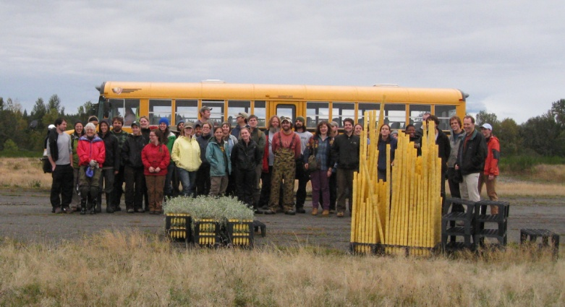

Endangered butterflies and old growth forests greeted the 2011 first-year Master of Environmental Studies students as we hit the ground running with two field trips. An excursion to the prairies of Joint Base Lewis-McChord (JBLM) was followed by adventures at the HJ Andrews Experimental Forest (HJA) in Oregon.

**JBLM Trip**

With backpacks, work gloves, field notebooks, and rubber boots at the ready, our cohort boarded a big yellow school bus and headed north to JBLM on Oct 4th. Two MES graduates, now biologists at JBLM, met us on site. Standing in the midst of a vast prairie, our hosts talked about prescribed burns and other maintenance measures required for the sensitive prairie habitat.

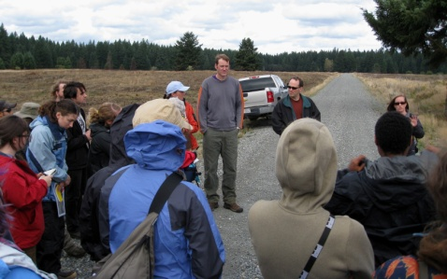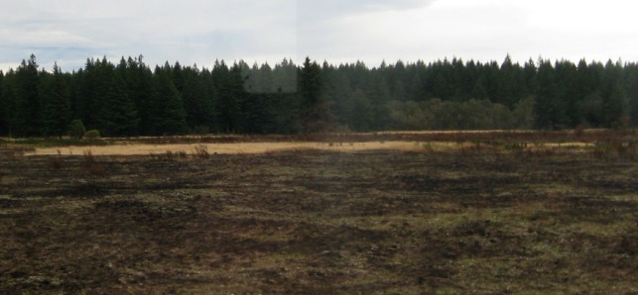

After a tour of other JBLM prairie sites, we met up with a group working to restore Taylor’s Checkerspot butterfly populations. The small colorful butterfly, once common in grasslands throughout the Pacific Northwest, is in danger of extinction due to disappearing habitat. MESers to the rescue! The peaceful prairie scene was interrupted by the roar of augers drilling shallow holes into which 3,600 Oregon Sunshine starts were inserted to promote the natural habitat for the Taylor’s Checkerspot.

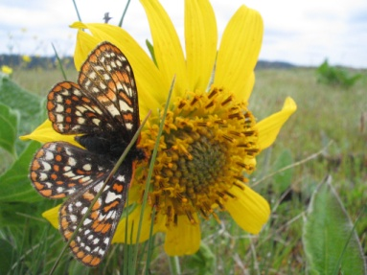

Photo from Oregon Fish and Wildlife Office website: http://www.fws.gov/oregonfwo/Species/PrairieSpecies/gallery.asp

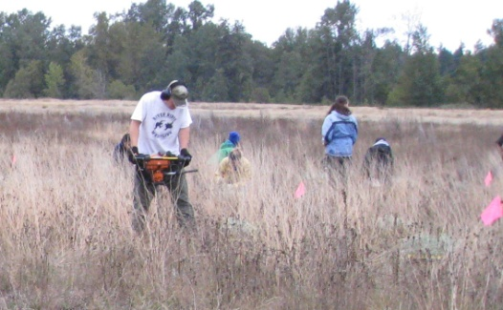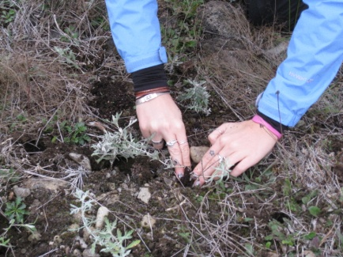

After hours of kneeling and planting—now seasoned restorers of habitats—we headed back to campus, ready for the next adventure.

**HJA Andrews Trip**

On October 13th, we boarded the big yellow bus once again: destination HJA. En route, we stopped at Oregon State University to attend fascinating lectures by Barbara Bond, Lead Principal Investigator (PI) at HJA, and Mark Harmon, former Lead PI.

After class discussions and reading Jon Luoma’s (1999) book, *The Hidden Forest*, everyone looked forward to experiencing the forest in person. That night we settled into comfy accommodations then gathered at the conference center for dinner Where Mark Schulze, HJA Forest Director and Evergreen alum, offered an intro to HJA and hyped up the fun active day ahead.

The following morning the group was off to explore the wonderful world of HJA. We were immersed in the natural beauty of the forest at three different sites. Along the way, Schulze talked about life cycles in the forest and explained various research projects. Donning hard hats, we hiked among the bases of towering old growth giants and marveled at the diversity of forest life. An enormous fallen log covered in soft green moss served as a perfect perch from which to enjoy lunch and view the surrounding beauty.

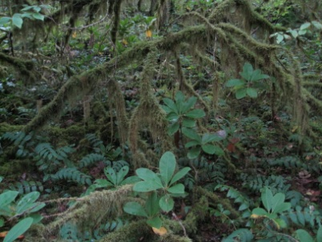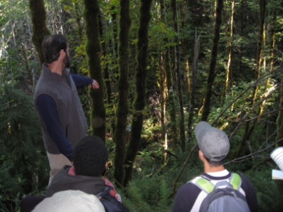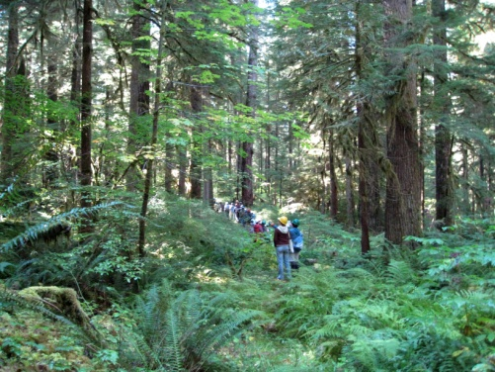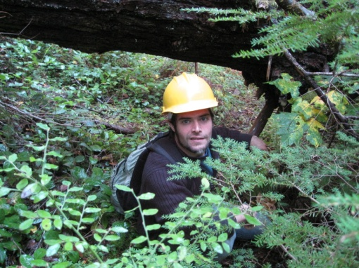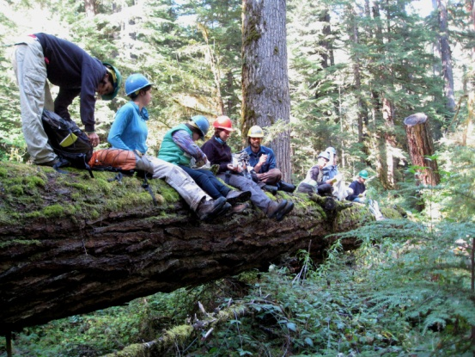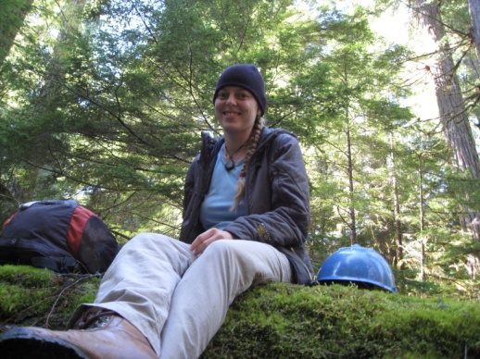

After lunch we ventured to a nearly 50 year-old Douglas fir plantation to continue the legacy of MES contributions to HJA research. We set up traverses, located vegetation plot centers, identified and measured trees, and performed understory work.

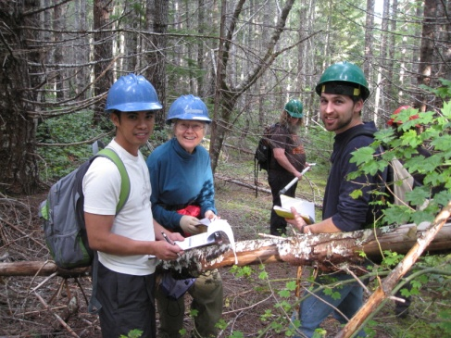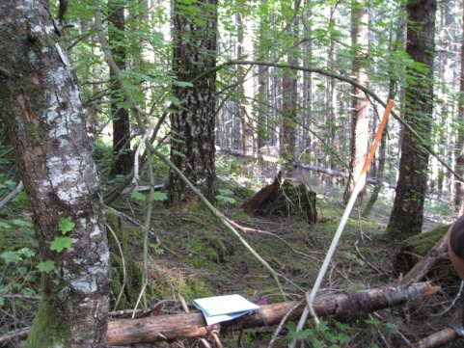

Along the way, we worked hard, learned a lot, had fun, and helped develop a base from which important research projects will proceed.

The next day the weary group traveled back to Olympia, recapping adventures and funny moments. Most of all, everyone couldn’t wait to get home and kick back. The 1st year MES students have earned their keep for the quarter, and if rumors are correct, we look forward to returning to both venues in the spring!

