***Fostering an appreciation for forests, one field trip at a time***

A five minute conversation charted my career course. It was during the summer between completing my B Sc. in botany at Washington State University and beginning graduate school at the University of British Columbia to study an invasive intertidal sea grass. My summer job was mapping intertidal and forest resources as part of an archeological project on the NW corner of the Olympic peninsula. The hope was that an understanding of past resource distribution would be a good predictor of seasonal camps of the landscape’s inhabitants thousands of years ago. It was a great summer. I wandered the intertidal and mapped the distribution of clams, mussels and urchins and pondered changes in intertidal habitat due to isostatic rebound after glaciations. I wandered the forests mapping plant associations that contained cedar and wetlands that grow basketry materials.

Across the river from our camp was the head office of the timber company that owned much of the surrounding commercial forest land. I really needed aerial photos to help my resource mapping. Foresters use aerial photos. It was an inevitable encounter. The chief forester was a personable chap; he had lived in the community for fifteen years, as had many of the other company employees. When I asked to borrow some aerial photos, I anticipated permission to perhaps come into their office and use a couple of stereo pairs at a time. To my utter shock, he produced the only complete set of photos in the office and said “they’re yours, we’re done.” That week the office was closing. All the available timber had been cut, the clearings burned, replanted, and sold to an investment company. “We’ll be back in 12 years to thin” the forester said (probably sensing my astonishment). I was thinking – that's no way to treat a forest-dependent community or a forest!

That brief conversation with the forester took root. I abandoned sea grasses after completing a M Sc. to study with a forest ecologist who looked at forests mostly as an ecological phenomenon, but also respected the social underpinnings. I have been doing the same for the last 25 years, working to return the forests of our landscape to predominance both physically and figuratively, and working to use forest science to change the world - one field trip at a time.

Over the last 25 years, I have seen forestry completely transform from the tail-end of the exploitation phase to the regulatory phase, and now flirt with ecosystem-based management. Forests influence every natural resource issue on our landscape. A basic understanding of site specificity, forest development, and habitat development is essential to be an effective participant in natural resource management issues. Without that understanding, one is susceptible to the merchants of doubt that lobby on both sides of every issue, often espousing distorted perceptions of how forests work. We owe it to our forested landscapes to be informed as how they did, do, and could even more so, support ecosystem functions.

Richard Bigley has been teaching MES electives related to forest ecology and management at Evergreen for years. He will teach a sustainable forestry MES elective the Fall of 2011 (field trips required).

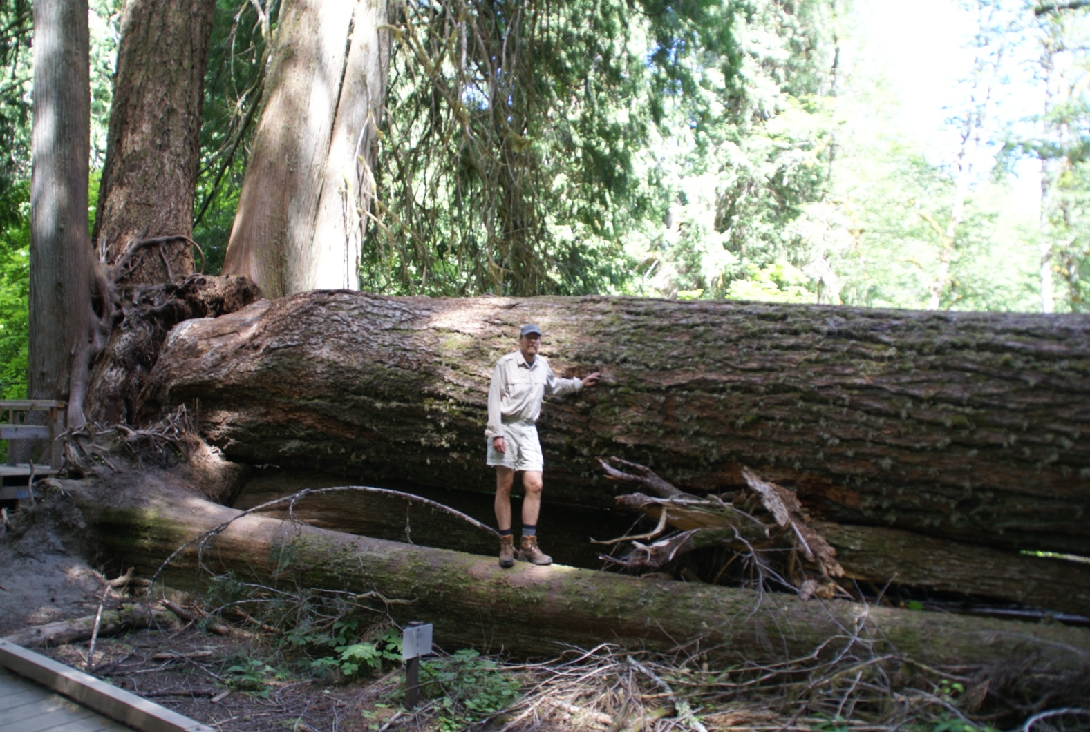

Richard in his natural habitat

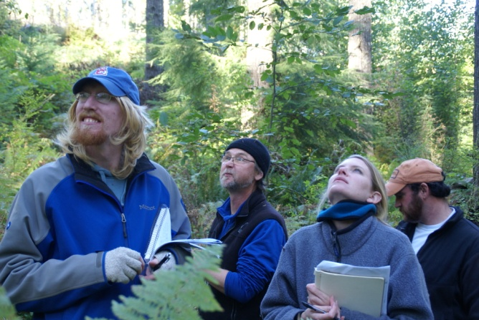

Students from the 2010 sustainable class

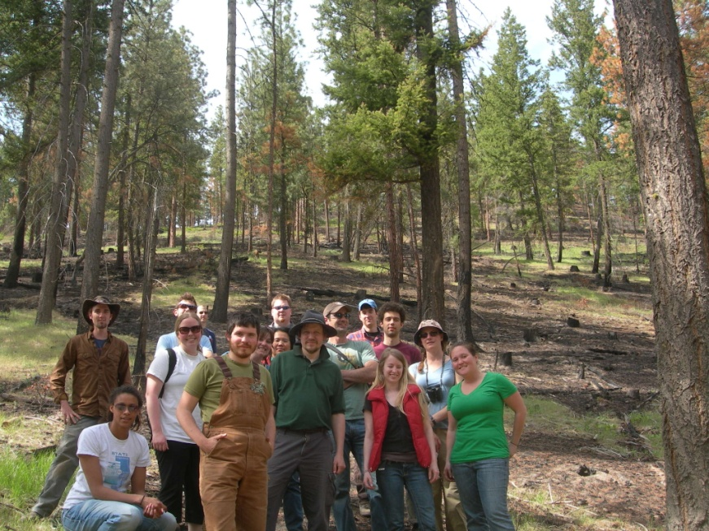

Students from the 2009 Forest Ecology class