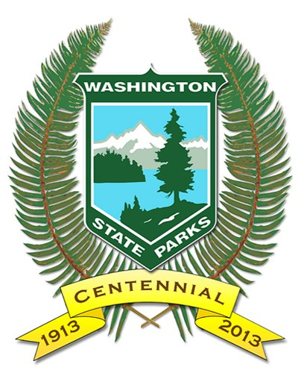 |  | WASHINGTON STATE PARKS AND RECREATION COMMISSION  VOLUNTEER PROGRAM  VOLUNTEER APPLICATION FOR INDIVIDUALS |  |  |  |  |  |  |  |  |  |  |  |  |  |  |  | Return this form to:  Washington State Parks  Volunteer Program  P O Box 42650  Olympia, WA 98504-2650
Purpose for Volunteering:  Hosting or long-term volunteer  An education requirement for K-12  An education requirement for college or internship  A court ordered requirement for community service  A project requirement for Eagle Scout or a service group  Community spirit (wanting to give something back to the community)  I am a: New Applicant Returning Applicant |  |  |  |  |  |  |  |  |  |  |  |  |  |  |  |  |  | FOR STATE PARKS PUPOSES ONLY  State Check Completed  Federal Check Completed  Results: Clear / Accepted  Not Clear / Accepted  Not Clear / Not Accepted  Application Processed  Application Entered
Name (1) Last, First, Middle Initial |  |  |  |  |  |  | Mr./Mrs./Ms./Miss: |  |  |  |  |  | Name (2) Last, First, Middle Initial |  |  |  |  |  |  |  |  |  |  | Mr./Mrs./Ms./Miss:
Birth Date Month/Day/Year (Required): |  |  |  |  |  |  | SS#: |  |  |  |  |  | Birth Date Month/Day/Year (Required): |  |  |  |  |  |  |  |  |  |  | SS#:
Mailing Address, City, State, Zip:

Telephone: |  |  |  |  |  |  | Cell Phone: |  |  |  |  |  |  |  |  |  | E-Mail:
Do you have a valid driver’s license? Yes No State: Driver’s License Number (s):
Have you taken a defensive driving course? Yes No Date:
Skills and Interests Volunteer 1 |  |  |  |  |  |  |  |  |  |  |  |  | Skills and Interests Volunteer 2
List any previous hosting or volunteer experience. Please list park, location, and dates. |  |  |  |  |  |  |  |  |  |  |  |  | If you have any work limitations, please explain:
What types of volunteer service would you like to provide?

Campground Host  Interpretive Host  ELC Host  Marine Park Host  Maintenance Host  Yurt/Cabin Host |  |  |  |  | Office Assistance  Computer Operation  Historical Park Research  Interpretive Assistance  Store Operations  Trade Shows |  |  |  |  |  |  |  | Jr. Ranger Program  Marine Education  Environmental  Flora/Fauna ID  Recycling  Trail Maintenance |  |  |  |  |  |  | Carpentry  Electrical  General Maintenance  Mechanical  Painting  Plumbing
Other: Interpretive Intern
List the State Parks where you would like to host or volunteer. If you would like to volunteer in any park within a certain geographical location, please indicate (i.e., ocean beaches, mountains, Puget Sound, lakes, desert, marine parks, etc).
1 | Ike Kinswa State Park |  | 2 | Seaquest State Park |  |  |  |  |  | 3 | Lewis and Clark State Park |  |  |  | 4 | Mount St. Helens Visitor Center |  |  |  |  | 5
If the parks you chose are full during the time you’re available, are you willing to host at other parks with openings? Yes No
Check months you are available to volunteer:
All Jan Feb Mar Apr May Jun Jul Aug Sep Oct Nov Dec Year 2017
Type of camping unit?  Motor Home 5th Wheel  Trailer Tent Moorage |  |  |  |  |  | Total length of campsite/moorage needed  10' 20' 25' 30' 35' 40'  45' 50' 55' 60' |  |  |  |  |  |  |  |  |  |  |  |  | RV Minimum hook-up necessary?  Water Sewer Electricity
Continue to Page 2
CRIMINAL BACKGROUND CHECK
As a volunteer, you will be acting as an agent of Washington State Parks. Many volunteer positions often have access to money or unsupervised access to children under sixteen years of age, developmentally disabled persons or vulnerable adults. In July 2005, the Washington State Legislature enacted into law, RCW 79A.05.030 (10) which requires volunteers of Washington State Parks to go through a criminal background check.
Volunteer 1 Volunteer 2
Have you been arrested or convicted of a misdemeanor or a felony? Yes No Yes No

Have you had any moving traffic violations in the last 2 years? Yes No Yes No

If yes, please attach explanation. If you have been convicted of a misdemeanor or felony, you may not be eligible for volunteer service, or you may be restricted from performing certain activities. State or Federal background checks will be done on all applicants.

All answers and statements are true and complete to the best of my knowledge. I understand that the state may verify information and that untruthful or misleading answers are cause for rejection of this application.

SIGNATURE VOLUNTEER 1 (REQUIRED): |  |  |  |  |  |  |  |  | DATE: |  |  |  | SIGNATURE VOLUNTEER 2 (REQUIRED): |  |  |  |  |  |  |  |  |  |  |  |  | DATE:
How did you learn of our program? Other Volunteer Newspaper Workamper News
NW State Park Ambassadors Trade Show Other

