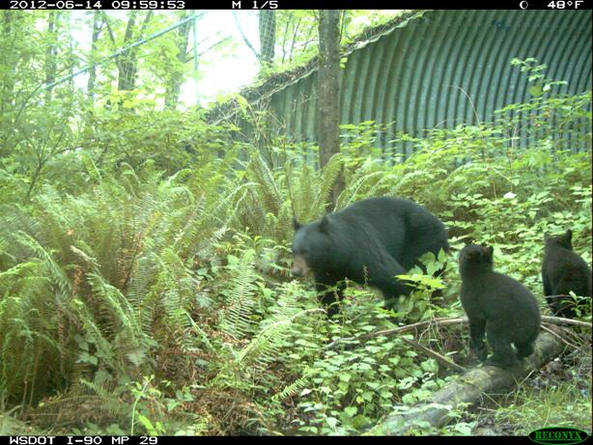

Internship with WSDOT:

**WSDOT is seeking to fill an internship** that runs for four quarters, summer and fall, 2014 and winter and spring 2015. The intern will:

* Work full time, 40 hours per week (32 hours paid, 8 hours instructional) during summer 2014 (can work fewer hours if needed)
* Work part time, 25 hours per week (19 hours paid, 6 hours instructional) during fall, winter, and spring quarters

Compensation is $11.00/hr

Duties:

* Service motion-triggered cameras deployed at bridges and culverts on the state highway system
* Review images and characterize wildlife detections in a master database
* Update the WSDOT wildlife carcass removal database
* Develop information materials related to wildlife and highways
* Analyze wildlife data and summarize in tables and graphs. Write reports.
* Assist other WSDOT biologists including fish moving associated with highway projects

Minimum Qualifications:

* Knowledge of Pacific Northwest wildlife, their ecology, life history, and behavior
* Ability to work outdoors in all weather conditions for up to 5 hours a day
* Ability to walk over rough terrain carrying 50 lbs.
* At least one college level statistics course
* Capable user of computers and Microsoft Office software
* Able to communicate clearly verbally and in writing in English
* Possess a valid Washington State driver’s license
* Must be an MES student who has earned credit in the first three core courses and hasn’t started their thesis yet.

To Apply:

Submit letter of interest and resume (by mail or email), by April 15, 2014 to:

Kelly McAllister

Washington State Department of Transportation

310 Maple Park SE

Olympia WA 98504-7331

mcallke@wsdot.wa.gov