To be posted on Tuesday, March 17th on the MES Facebook page:

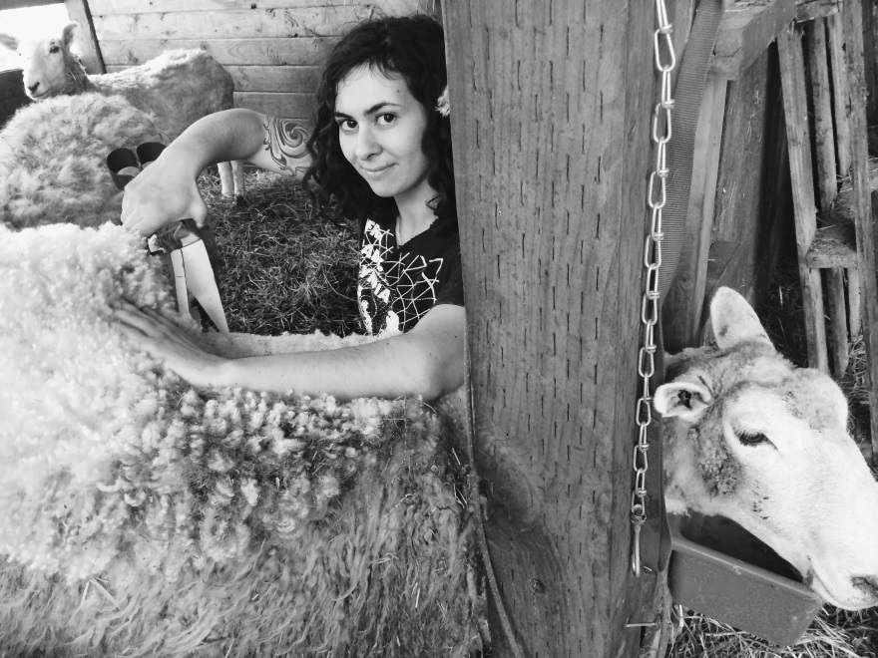

Lisa Abdulghani (MES ’14) shears Agnes, a member of her flock. This year, Lisa is making cheese, spinning wool, and eating lamb she raised herself. MES alumni are always up to something interesting. Come see what your fellow alums are growing and creating at the 30th anniversary event, #MES30. Register soon! <http://bit.ly/1NmnS9Gg>

To be posted Tuesday, March 17th on the MES Twitter:

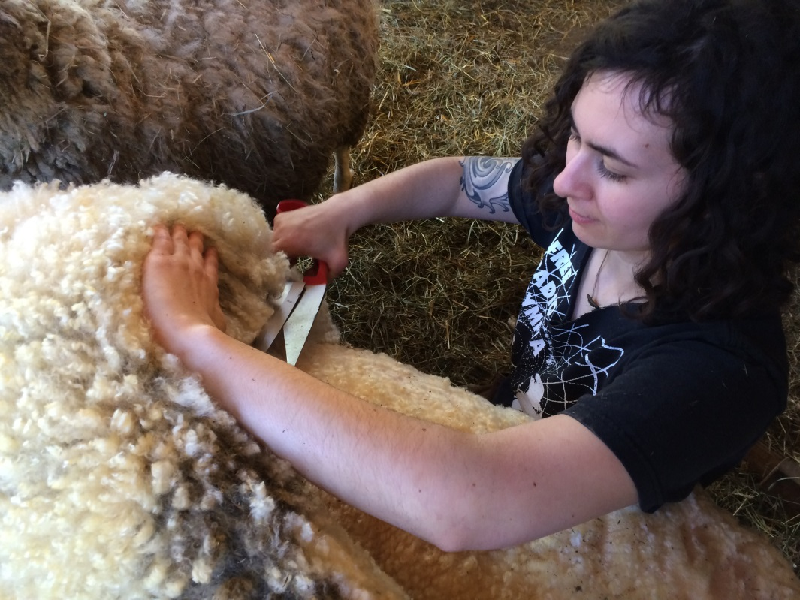

Lisa (’12) shears Agnes, a member of her flock – come see what other alumni are up to at #MES30. Have you registered yet? <http://bit.ly/1NmnS9G>

To be posted on Thursday, March 19th to the MES Instagram page:

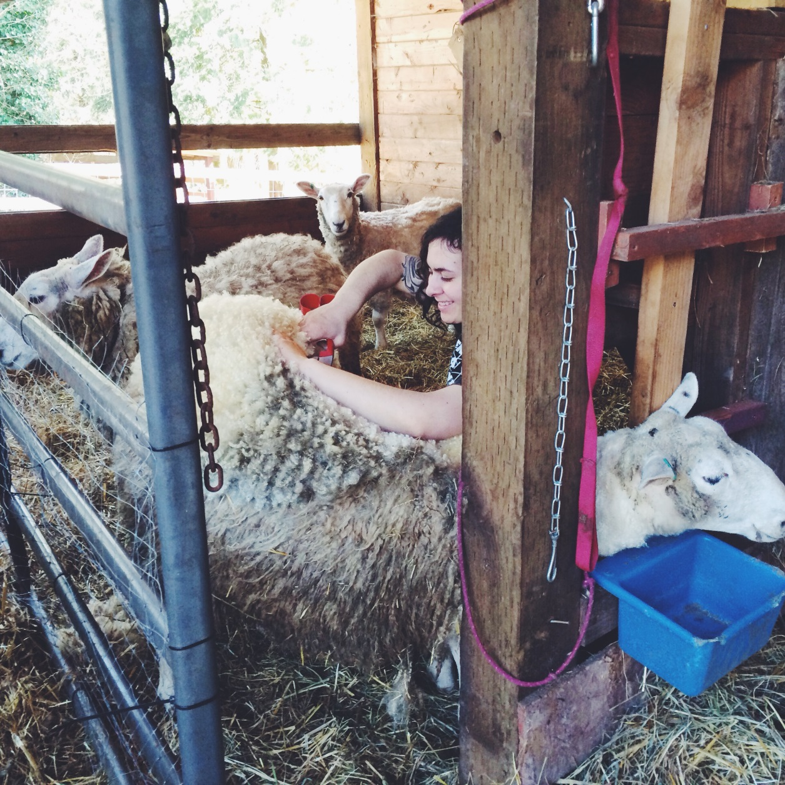

#tbt to last weekend with @leesaah and Agnes. When she’s not working with Seattle Shellfish as a research biologist, Lisa (MES ’14) is rearing her first flock of sheep in the heart of Mason County. Register for #MES30 and see what your fellow MES alumni are up to! <http://bit.ly/1NmnS9G>