To be posted Tuesday, March 10th on the MES Facebook page:

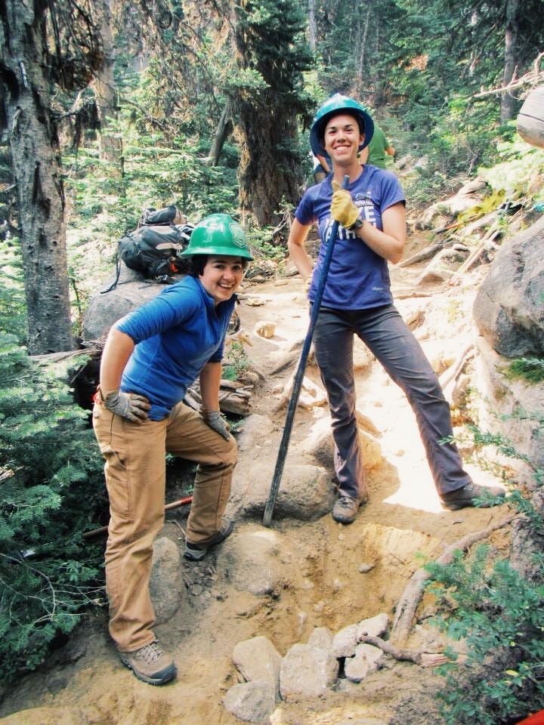

Andrea Martin (MES ’13) is gearing up for another summer of leading youth on trailbuilds with [Washington Trails Association](https://www.facebook.com/washingtontrails). Are you an alum? Share some of your current work in the comments and come network at our 30th anniversary event, #MES30. Register by April 15! <http://bit.ly/1NmnS9G>

To be posted Tuesday, March 10th on the MES Twitter account:

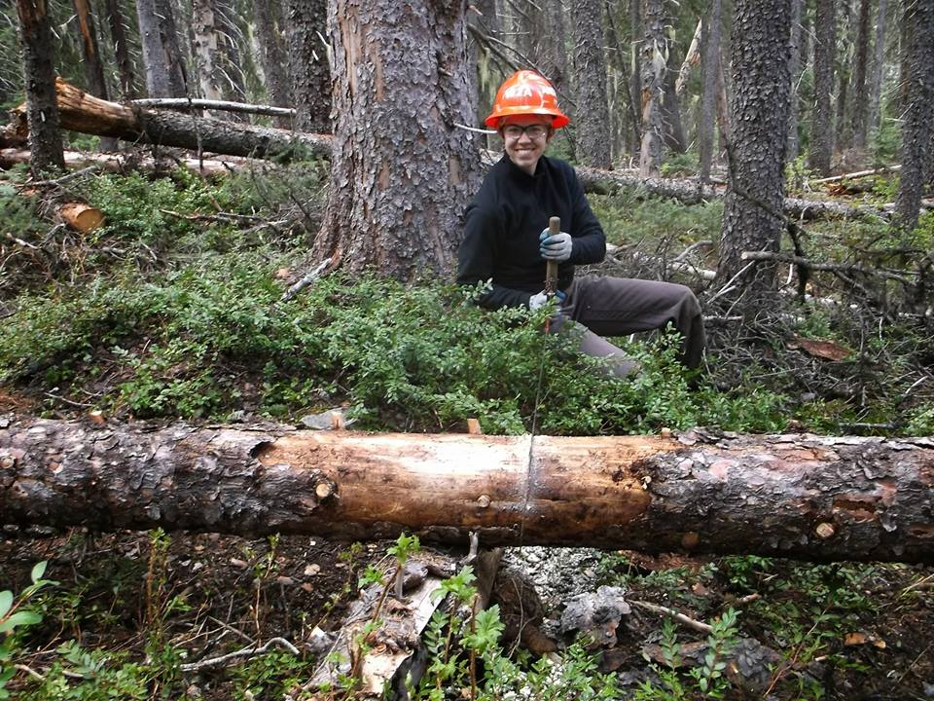

Andrea (MES ’13) leads youth crews on trailbuilds with @wta_hikers. Network with other MES alumni- register for #MES30 by April 15! <http://bit.ly/1NmnS9G>

To be posted Thursday, March 12th on the MES Instagram:

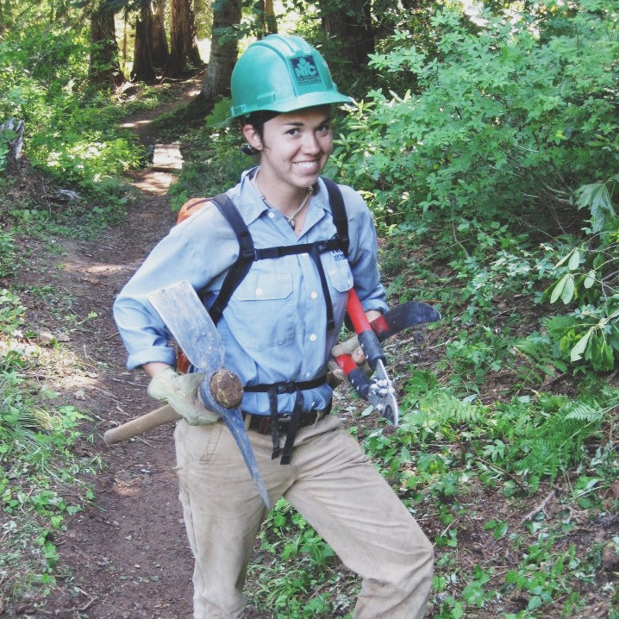

#tbt to alum @andreeasuzanne ‘s first job as a trailbuilder with Northwest Youth Corps. Andrea (MES ’13) now leads youth trail crews with @washingtontrails all over Washington. Alumni – where are you working? Register for our 30th anniversary bash and use #MES30 to share your work. <http://bit.ly/1NmnS9G>