
GIS Certificate
The Evergreen State College
This is to certify that
Elizabeth Torres
Successfully completed the requirements for the
Geographic Information Systems Certificate from the Master of Environmental Studies Program at The Evergreen State College,
Winter of 2022
 |  |  | 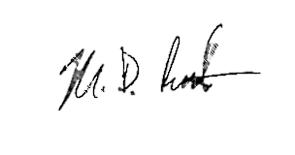
 | Kevin Francis, Ph.D., Director  Master of Environmental Studies Program |  | Mike Ruth, M.Sc.  Geographic Information Systems Instructor

GIS Certificate
The Evergreen State College
This is to certify that
Marissa Scoville
Successfully completed the requirements for the
Geographic Information Systems Certificate from the Master of Environmental Studies Program at The Evergreen State College,
Winter of 2022
 | Kevin Francis, Ph.D., Director  Master of Environmental Studies Program |  | Mike Ruth, M.Sc.  Geographic Information Systems Instructor

GIS Certificate
The Evergreen State College
This is to certify that
Sarah Mangum
Successfully completed the requirements for the
Geographic Information Systems Certificate from the Master of Environmental Studies Program at The Evergreen State College,
Winter of 2022
 | Kevin Francis, Ph.D., Director  Master of Environmental Studies Program |  | Mike Ruth, M.Sc.  Geographic Information Systems Instructor

