
GIS Certificate
The Evergreen State College
This is to certify that
«First_Name» «Last_Name»
Successfully completed the requirements for the
Geographic Information Systems Certificate in the Master of Environmental Studies Program at The Evergreen State College,
Winter of 2022
 |  |  | 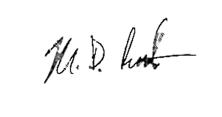
 | Kevin Francis, Ph.D., Director  Master of Environmental Studies Program |  | Mike Ruth, M.Sc.  Geographic Information Systems Instructor

