Submitting CollegeNet annual changes 3/26/14

ACR = annual change request, allowed for free once/year, one complete set submitted together at same time

Can be submitted anytime in calendar year, June 1 – Aug 31 is busiest time and turnaround is slower, so they recommend submitting changes 2 months prior to your deadline and plan for as much as a month of testing and follow-up before going live

-all pending change requests (outside of annual change) must be complete before they can start on annual changes

Q – do they keep things the same that we don’t ask to change?

If our deadline is Oct 1, it sounds to me like we need to submit by Aug 1 – confirm

Biggest issue – NOTE ANY CODES THAT ARE NEEDED IN YOUR DOWNLOAD FILE – what does this mean? I think it’s for people with a CRM.

Also, if you add a new question to the form, make sure you also add it to the PDF.

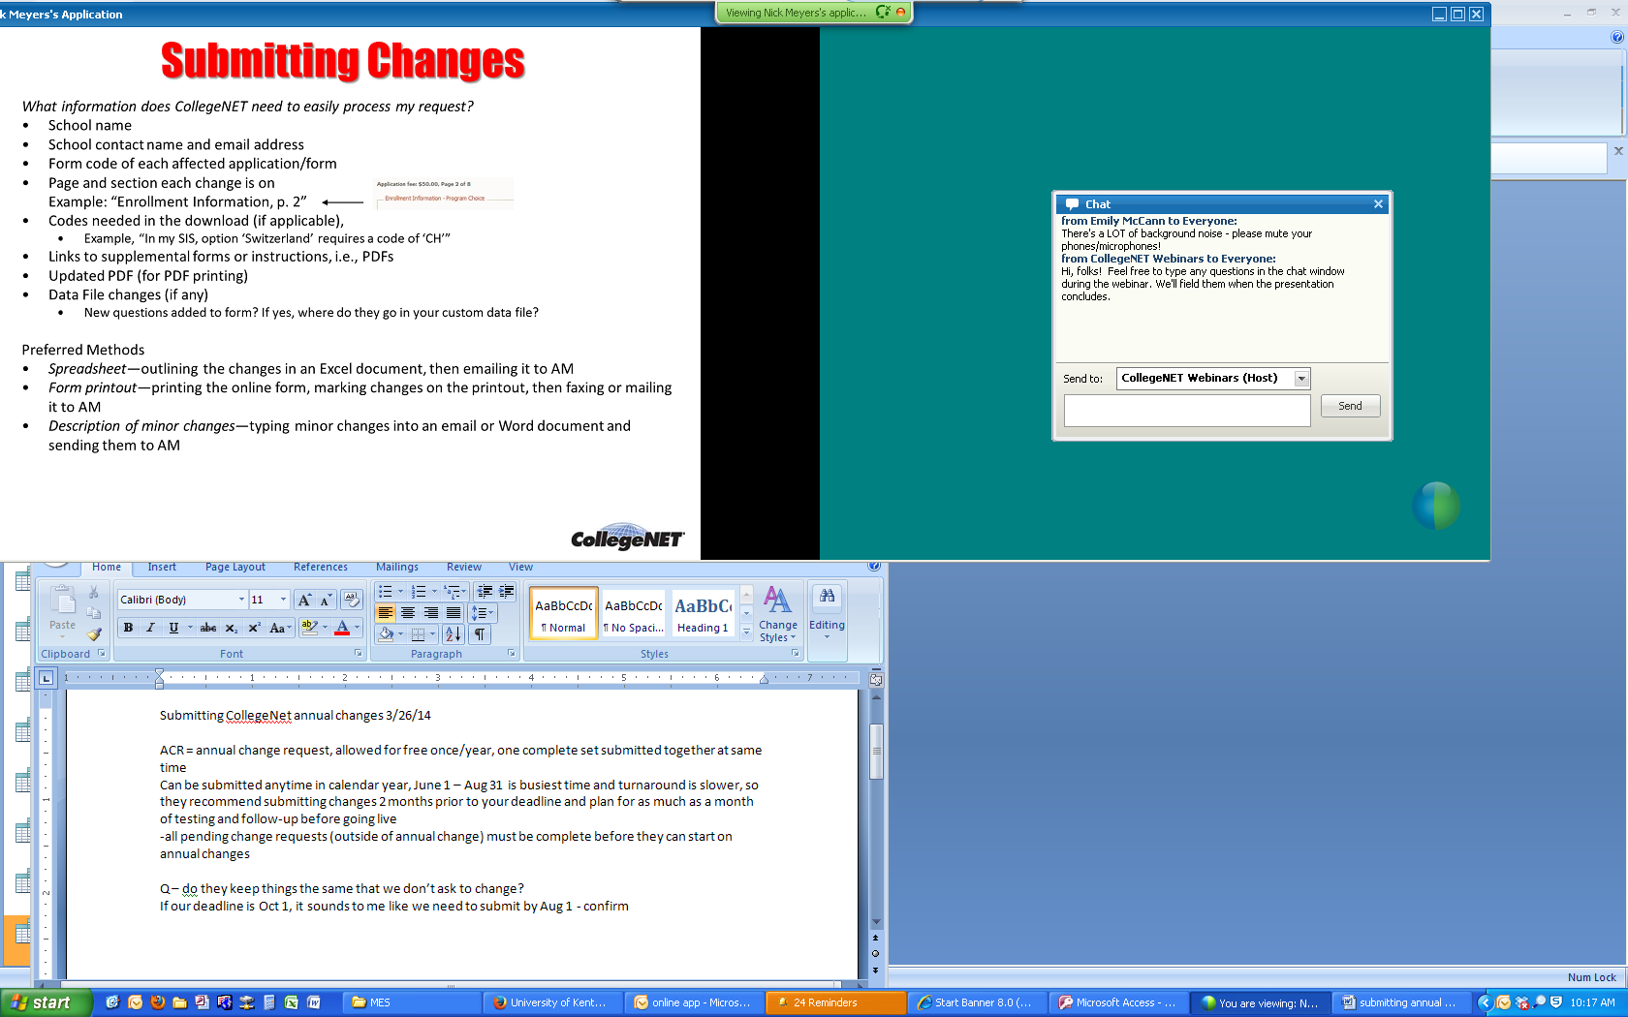

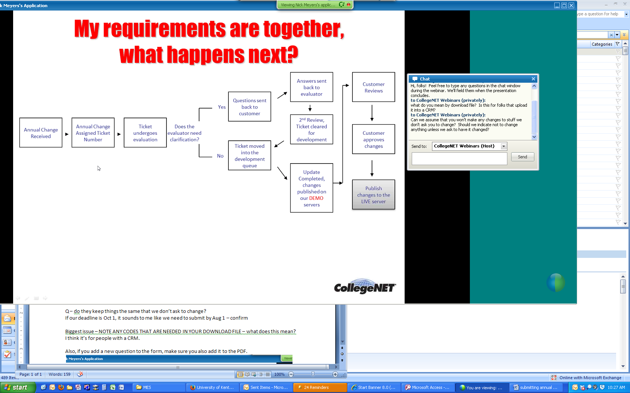

Remember to update your e-sponses, etc before it goes live!! (note from gail – find out exactly when they are going live – I don’t think this was communicated well before)

-make sure ticket numbers are in your email subject (ex: Ticket: A4F1DDD8AFDFDEFD)

-test the PDF before the app goes live.

-Your editable pieces are terms and e-sponses/triggers. You can make these changes at any time.

-They will only change things that are noted or marked. If something is left alone, they won’t change it. (although, we know from experience that we have to check that they didn’t make changes on stuff we didn’t ask them to change)

The amount of time you take for review is up to you – so you could take 1 day or 1 month.

If someone starts the app and then goes back in after the change, there will be a note letting them know changes have been made to the application.

