CollegeNet letters & checklist

Here is how they get the letter – there is a ‘view your decision letter’ button

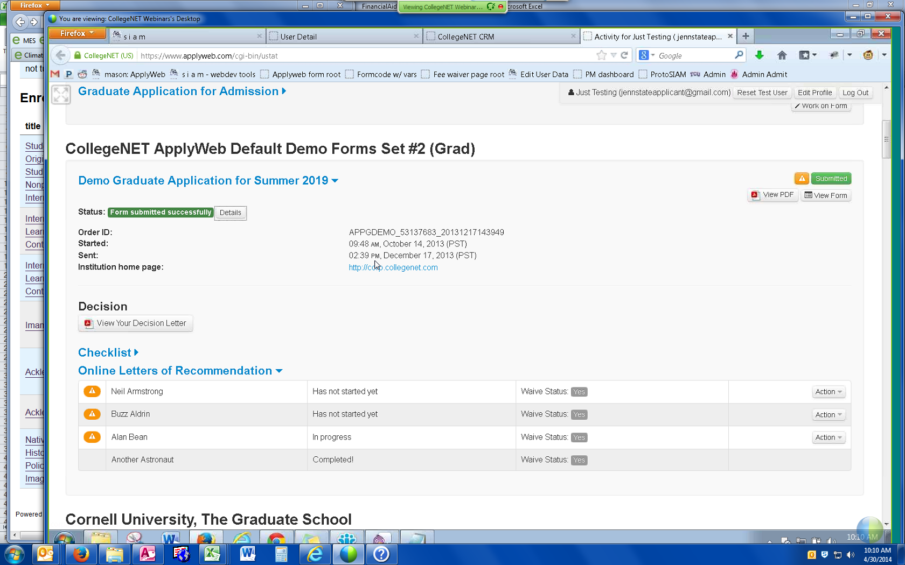

Here is what the checklist looks like:

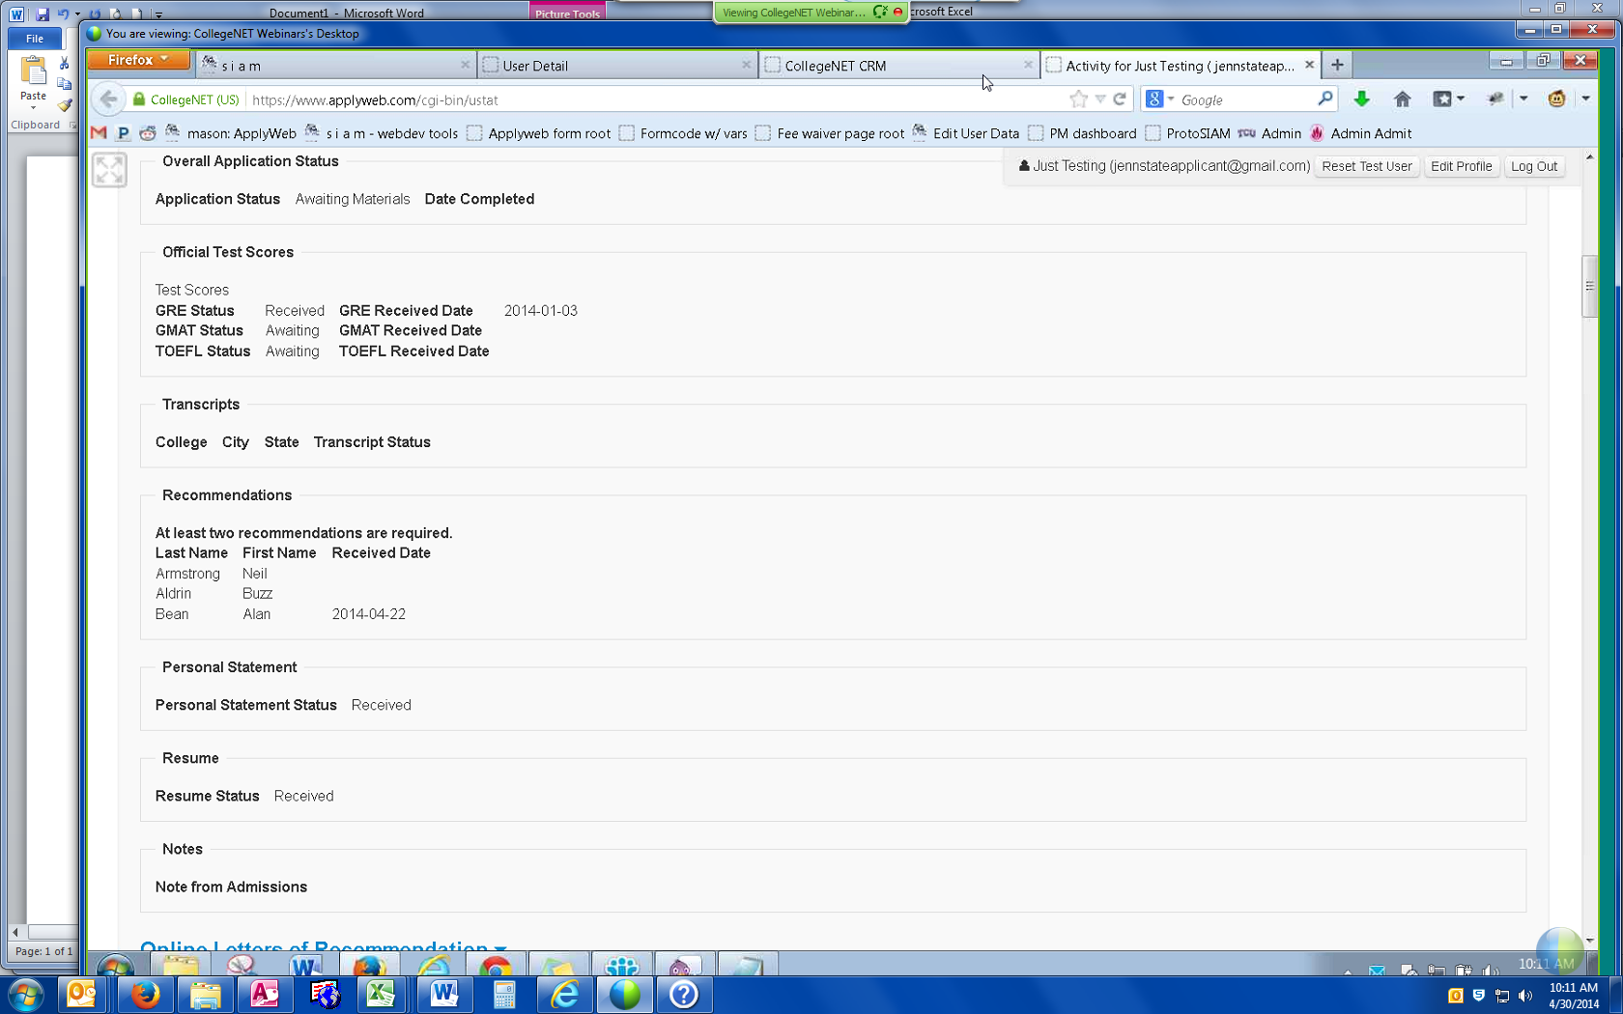

ADs would need to enter the data manually into CollegeNet or upload from Banner to CollegeNet on the backend. Can also waive requirements in CollegeNet so that it says ‘waived’ on the checklist. Can also include a note from Admissions office that shows up on checklist – like ‘we received your transcript, but it wasn’t official’ or something along those lines.

Applicants can upload post-admissions documents through their user status page.

Can create the admit letter on collegenet – allows you to use logos and write all sorts of different templates. Can pull the fields from collegenet. Sounds like we might be able to write more than one letter (could add a financial aid letter, for example). Check with mark. Example:

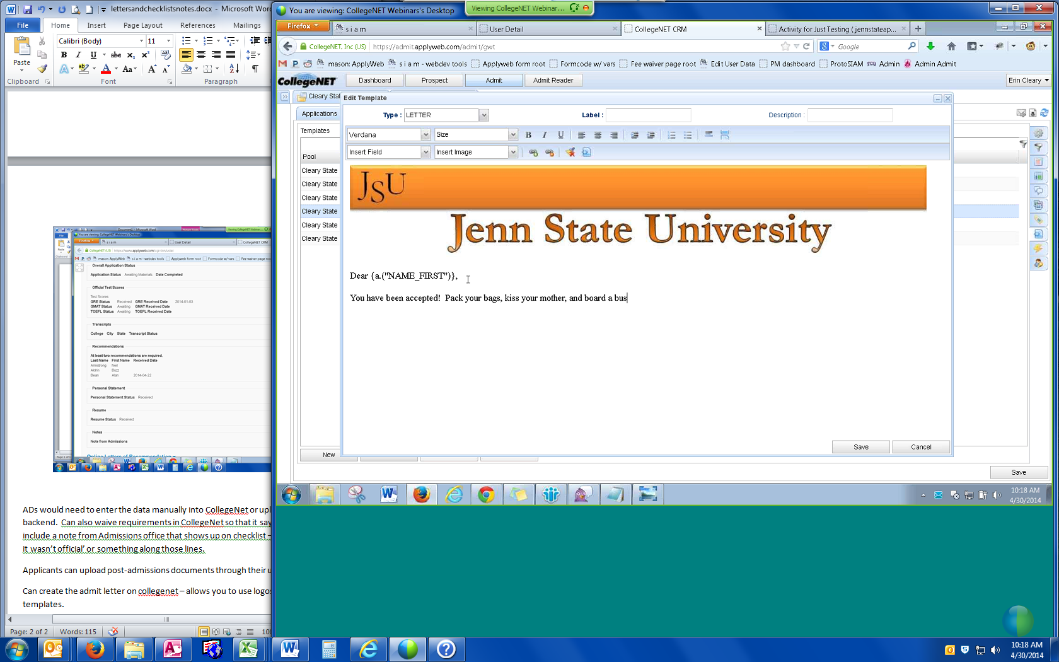

Student can reply through the admission decision page. Or decline, defer – if declining, can be asked why they aren’t coming (like my survey I already do). Can have unlimited # of letter templates.

The software is called the ‘applicant portal’ and isn’t the full admit software.

Full implementation of admit allows you to make changes at any time. If doing the standalone, you have control over how to organize things after you go live, although there are some limitations where you can’t make certain changes. Have to ask mark.

Most schools choose checklist/decision letters instead of just one.

Also, instead of what we use for the standard collegenet, we will have something that is better in looking at our apps. Can also move an app to ‘ready to review’ where the committee can make decisions online vs on paper. They can enter notes in there for the whole committee to see (this would be good for denied students):

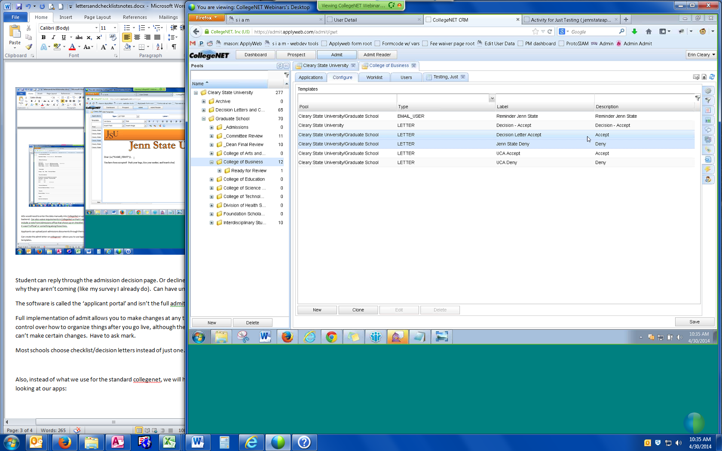

This is basically like a mini-CRM. Can send emails through collegenet vs. emma. Allows you to insert images like Emma.