How to create a Program Enrollment Summary from the CMD

[my.evergreen.edu/offerings/manage](http://my.evergreen.edu/offerings/manage)

The view will default to the current academic year.

On the right side of the screen, under **Collections** click on “Collection Manager Application”

A new view “Collections” will open

Search for MPA

Select the collection made for the current academic year – Example: “MPA 21-22”

A new view will open with the collection – Example “MPA 21-22”

A new view will open with the Collection Dashboard

Once registration is open, there will be a link next to the quarter with **enrollment numbers**

Click on that number to get the Program Enrollment Summary

NOTE- it doesn't exist until someone registers or students are automatically registered “rolled” to the core class for the following quarter. (“Rolling” does not apply to transition between 1st Yr to 2nd Year OR from ATPS II to CAPSTONE.)

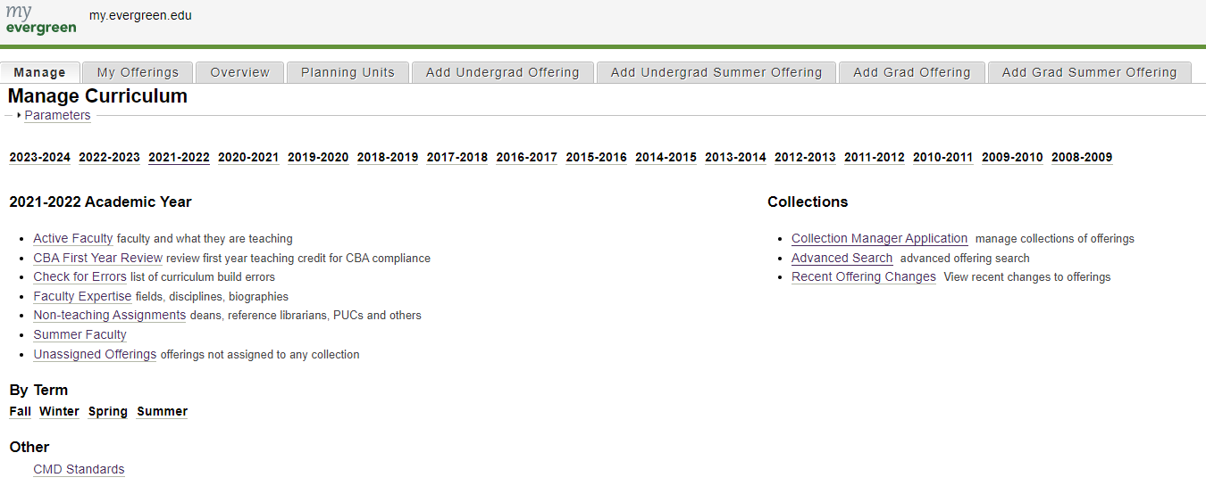

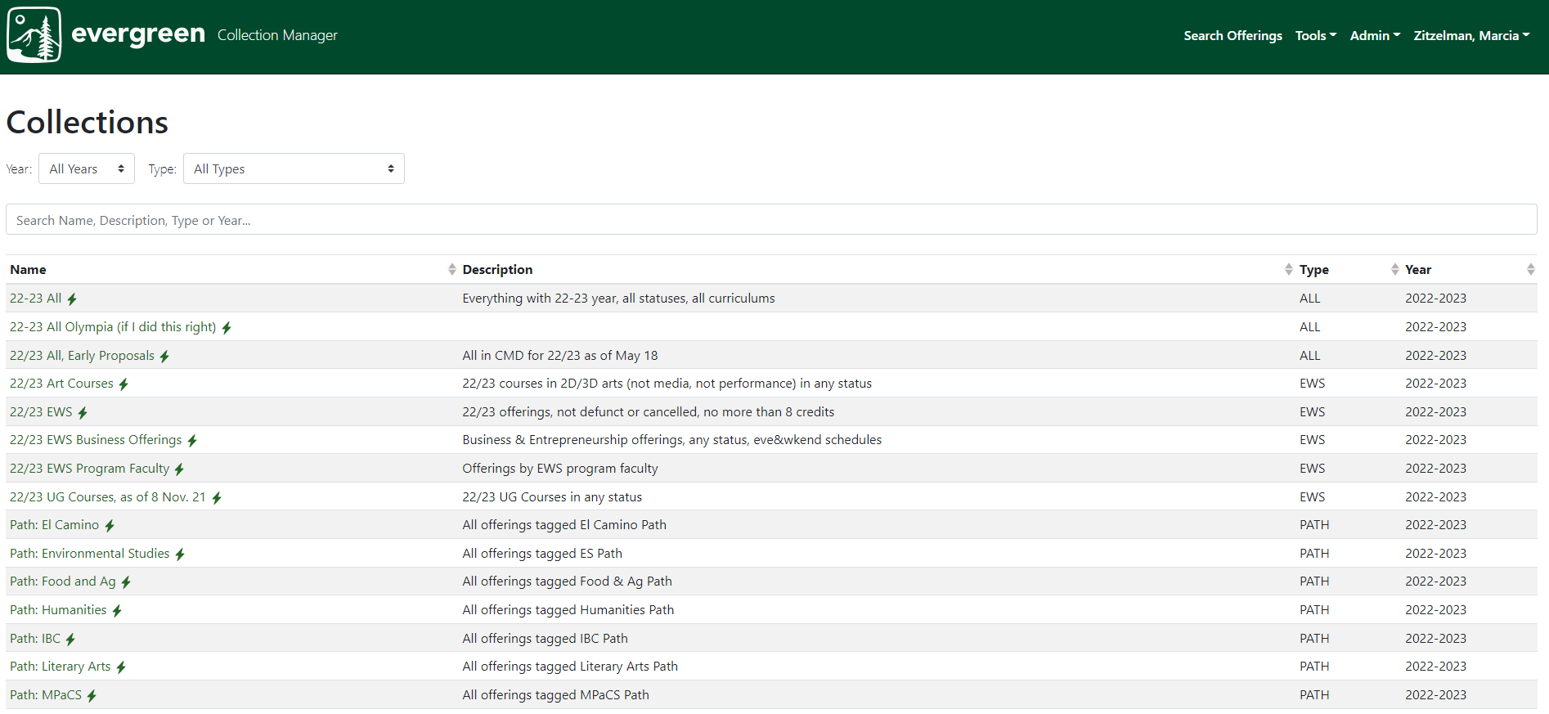

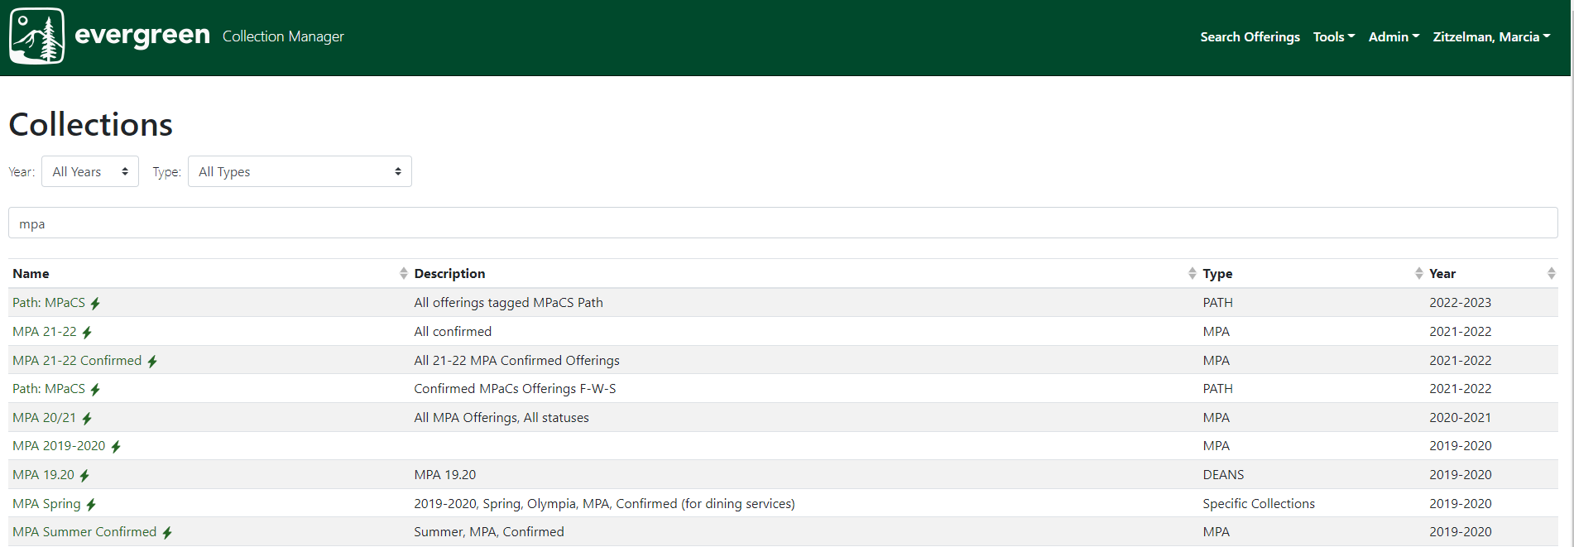

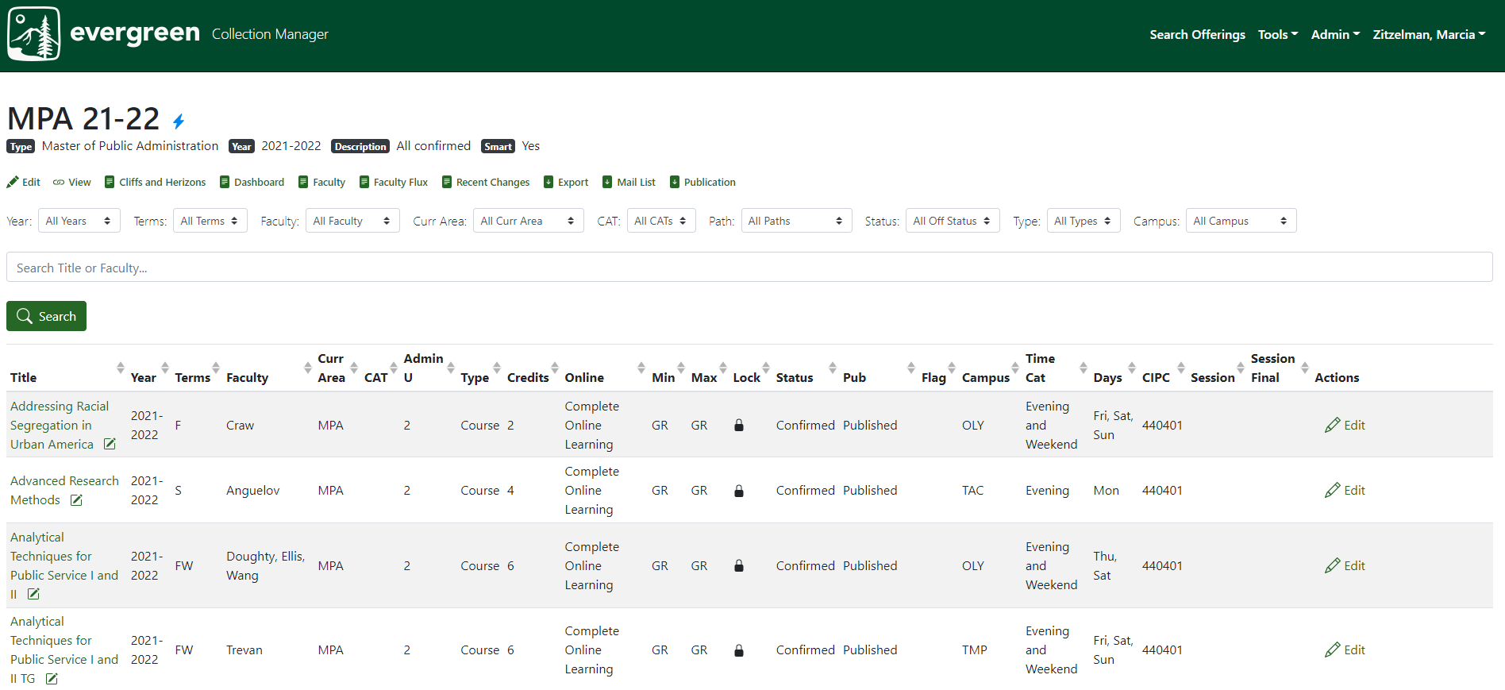

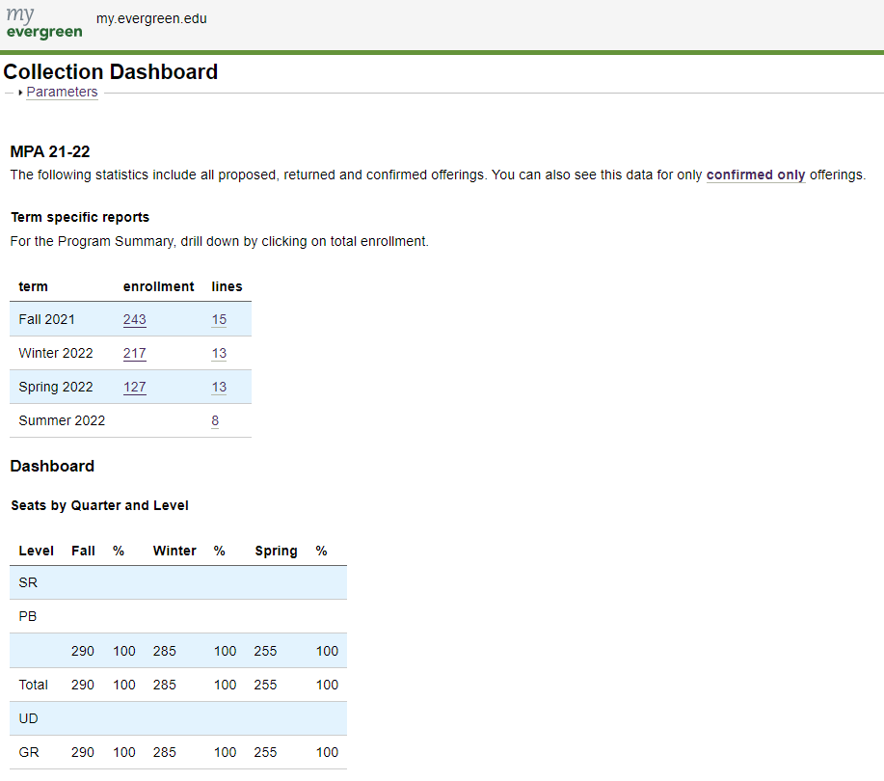

Final Result – the Program Enrollment Summary:

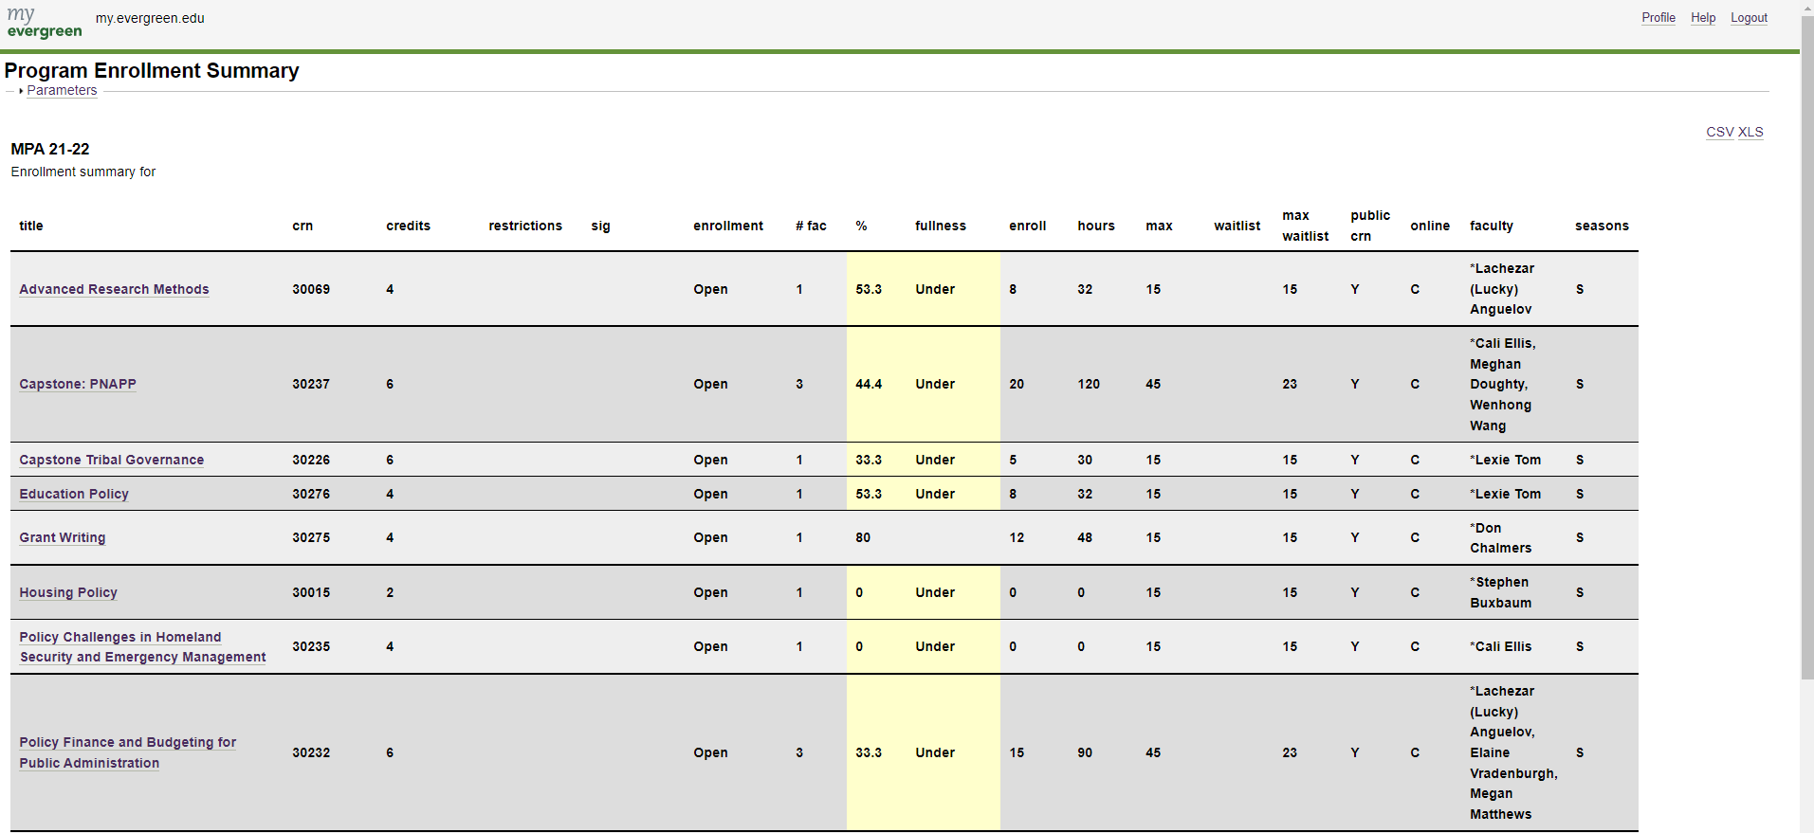

Bookmark and save this website!