Budget Tracking 101

(Make an appointment with Tina Pearson and/or Michelle Bartlett to go over this, too! Maybe you and John can go together?)

You will be managing three budgets:

**25101 – MES Support**

This budget pays for all the outreach and recruitment expenses, including program assistant and ambassadors, travel, purchasing food for events, postage, outreach materials, etc. – Can track expenses in your my.evergreen.edu account

**25102 – MES Academic**

This budget pays for the GIS and Stats tutors, as well as the writing tutor(s). This is also where charges for guest speakers, books and materials for classes, and occasionally travel fees for classes can be charges to. This is a much smaller budget than the support budget. Work with Kevin/John to decide who is tracking this and how. – Can track expenses in your my.evergreen.edu account

**25120 – MES Thesis Fund**

This is where all the $500 thesis extension fees go during the regular academic year (in the summer they go directly to faculty). This fund is used almost exclusively to support MES student research. There is a competitive application process for Case Studies students to apply for funding at the end of fall quarter to use for thesis expenses. MES Director can also allow additional expenses related to research to be charged to this fund. You cannot track this in your My Evergreen account. Ask Tina or Michelle to check on balance when you need it.

To create a budget inquiry in your My Evergreen account:

1. You want to look at the budget by account

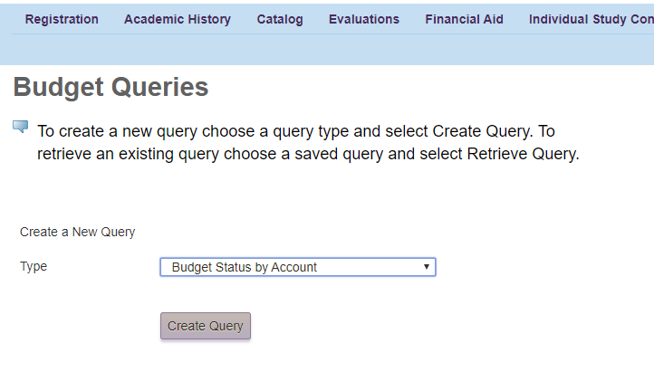

1. Check the boxes below to see the most accurate picture available (I never save a query, but you could – you might want to check with Tina on how/why)

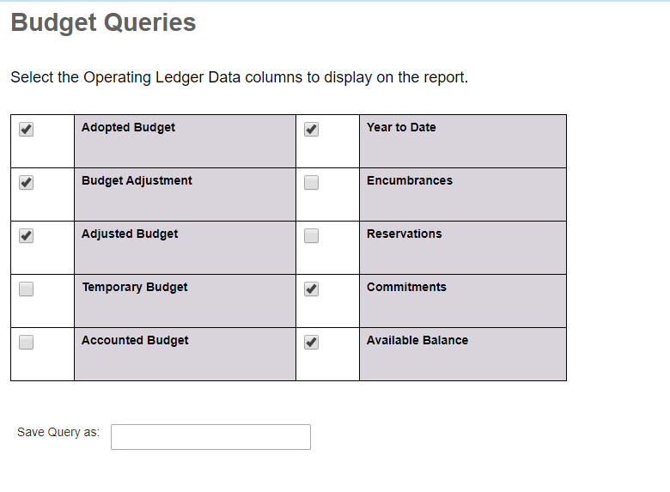

1. Use the data below to run the query you want. Using Fiscal period 14 will show you the full year to date, versus a slice of the fiscal year. Enter the Org code you want to review in the Organization field. If you want to look at what you’ve spent so far on travel, you could enter the account code for travel in that field (account code cheat sheet available on O Drive!). Then click the “Submit Query” button on the bottom of the page.
2. When you get the budget report, you’ll see that many sections are hyperlinked, so you can click through and see where money was spent, and on what. You can also download the full report to do your own tracking of future expenses (examples in O Drive)

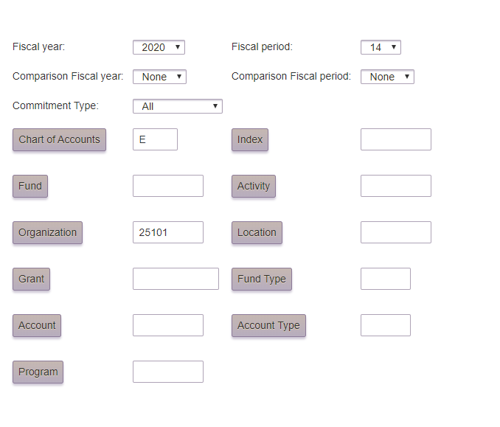

Other tips:

**Budget balancing**: While you have allocated funds in Goods and Services, Travel and Personnel, it’s fine to go over in some areas as long as your total organizational budget doesn’t go over. In my experience, we always go over in Goods and Services and/or in student employees, but rarely go over in travel. Just make sure you can pay for it somewhere.

**Work study**: the MES Support budget has been pretty easy to manage over the last year and a half because Trudy gets the majority of her compensation through Work Study funds. If you can hire another program assistant who can take at least part of their compensation in work study, do it. If you need to pay $13.50/hour out of your operational budget, you probably can’t afford Ambassadors, or the position can’t be 20 hours/week. There are some budget breakdowns in the O Drive that spell out some options you’ll need to consider.

**Student employees and summer**: Also important to remember that work study is not available in the summer. And, if a student employee isn’t in classes, they are considered a temporary employee, and cost more. You’ll need to be really creative and proactive in communicating options for summer work (you likely can’t afford an average of 20 hours/week all summer)

**The fiscal year at Evergreen** is from July 1 to June 30. This is important to remember because you want all your graduation/end of the year expenses to be charged to the year ending. So, try to get everything paid for as far in advance as possible. It’s also a good idea to audit your expenses in the spring to see if you’ll be under budget. If you will, this is a good chance to pay for a conference or buy a plane ticket for recruitment travel, or to stock up on outreach brochures, envelopes, letterhead, stickers, etc. that you don’t want to be charged to your next year’s budget.

Some tips for travel:

* Do a blanket travel authority for yourself for the 19-20 academic year, and then again in September for the 20-21 academic year. This will save you a ton of time and paperwork on recruitment travel.
* Make sure Travel Authorities are done in advance for all student staff travel
* Pay for as much as possible in advance through Michelle Bartlett. This includes hotel reservations, fair registrations, rental cars, etc.
* If you need to buy plane tickets, go through Jane at Classic Travel. You MUST have a Travel Authority on file before you can purchase a plane ticket.
* You can save some money on travel by staying in AirB&B or VRBO, but you will need to pay for this in advance with your money and get reimbursed.