March 13, 2012

Eryn Farkas
Tim Benedict
Teal Waterstrat

Dear

Thank you for showing your commitment to environmental sustainability by applying for the 2012 Margaret A. Cargill Sustainability Fellowship (which has recently been renamed the Evergreen Sustainability Fellowship). We received several intriguing project ideas this round and were not able to offer you a fellowship this time.

If you will be a student in the 2012-2013 academic year, you will be able to apply again in Winter 2013. Also, please remember that MES Financial Aid applications are due April 11 for the 2012-2013 academic year.

Sincerely,

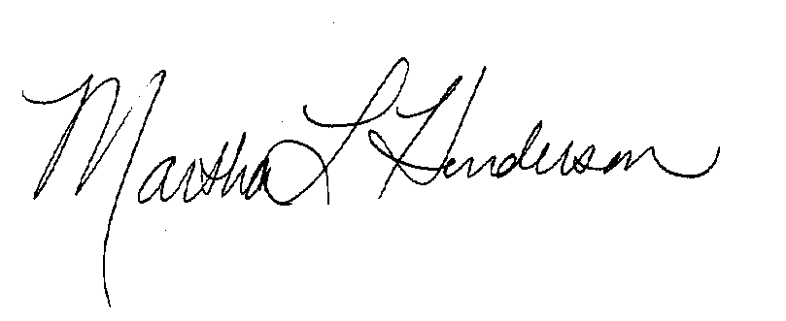

Martha Henderson

Director, Graduate Program on the Environment

