March 13, 2012

Jennie Husby
Kyle Pinjuv
Kim Jones

Dear NAME,

Congratulations! This letter is to confirm your acceptance as a 2012 Evergreen Sustainability Fellow (the Margaret A. Cargill Sustainability Fellowship has recently been renamed the Evergreen Sustainability Fellowship). Please review the position responsibilities, next steps, and conditions below, and then indicate your formal acceptance of this position under the terms specified by signing below. Return this original letter to the MES Assistant Director as soon as possible. Please keep a copy for your records.

Fellowship responsibility: To complete a project that contributes to your academic learning while furthering the environmental sustainability goals of The Evergreen State College and/or a non-Evergreen community.

Your final deliverables are:
- A field supervisor’s report affirming satisfactory accomplishment of your project (due to the MES office)
- A 3-5 page written project summary report which “tells the story” of the project to (1) the MES program (wootang@evergreen.edu) and (2) the Office of Advancement (Megan Oczkewicz at oczkewim@evergreen.edu).

Next Steps:

- Email Gail Wootan at wootang@evergreen.edu letting her know which quarter you intend to start your project (Spring 2012 or Summer 2012) and when we should expect the final deliverables.
- If you plan to take either internship or thesis credits for this project, make sure to do so by day 5 of the quarter to avoid fees.
- If you are planning to do this for internship credit, please see your MES student handbook for instructions on signing up for internship credit.

Fellowship Award: The Cargill Sustainability Fellowship award is $4000, payable at the beginning of the quarter in which you begin to perform your work, which will either be Spring 2012 or Summer 2012. Keep in mind that you must be taking at least two credits (of anything) the quarter in which the funds are disbursed to your account.

We are pleased to be able to support your commitment to environmental studies and sustainability, and we look forward to working with you.

Sincerely,
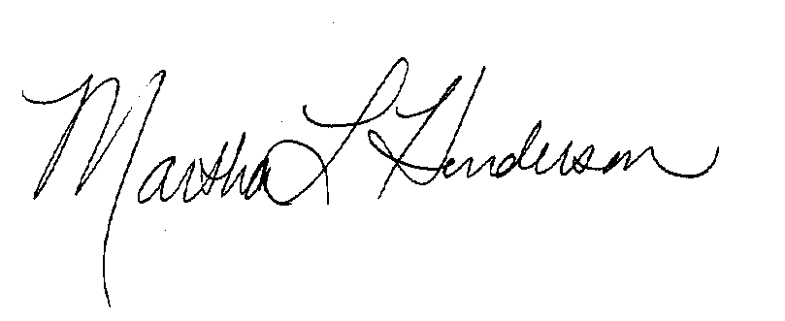
Martha Henderson
Director, Graduate Program on the Environment

POSITION ACCEPTANCE

I, _________________________, accept the Evergreen Sustainability Fellowship and the terms and conditions specified in this letter.

_________________________________________ _____________________
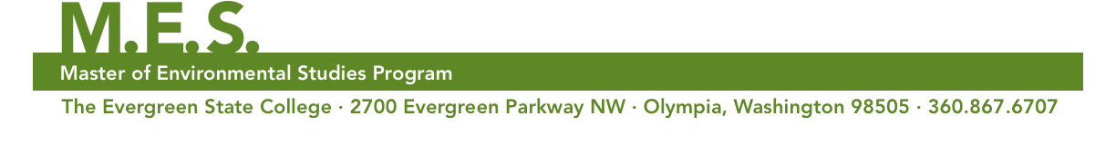
(Signature) (Date)

