March 31, 2025
Student ID: A00453809

Dear Anushka,

Congratulations! It is my pleasure to inform you that you have been selected to receive the Foundation Graduate Fellowship Award from the Graduate Program on the Environment at The Evergreen State College.

This award is a non-renewable scholarship of $6,500 for the 2025-2026 academic year. The amount will be credited to your student account in three instalments equal to a third of this amount for Fall, Winter and Spring Quarters as long as you are registered for at least eight MES credits per quarter.

Please note that adjustments to your aid are likely to occur if there are changes to your status, such as changes to enrollment status, number of credit hours, residency status, etc. In addition, increased personal resources may result in decreases to other financial aid awards including possible repayment for financial aid you have already received, including loan proceeds.

In order to accept this award, please login to your scholarship application portal in AwardSpring to accept the terms of the award by June 1st, 2025
If you have any questions about this award, please contact the MES office at 360-742-8746 or averi.a.azar@evergreen.edu.

If you have any questions about loans, please contact Financial Aid at 360-867-6205.

Sincerely,
Carri LeRoy

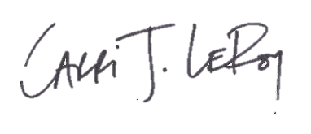
Carri LeRoy, Ph.D.
Director, Master of Environmental Studies Program
leroyc@evergreen.edu

