May 17, 2024 Student ID: A00396604

Dear Xitlali,

Congratulations! It is my pleasure to inform you that you have been selected as the recipient of the 2024-2025 Sara Ann Bilezikian Fellowship by the Graduate Program on the Environment at The Evergreen State College. The fellowship is in the amount of $12,795 for the 2024-2025 academic year. The 2024-2025 award will be credited to your student account in three installments each equal to a third of this amount for Fall, Winter and Spring Quarters as long as you are enrolled for at least 8 credits as an MES student.

This award reflects the judgment of the selection committee that you have demonstrated an exceptionally strong commitment to environmental improvement and social justice. Sara Ann Bilezikian, who graduated from Evergreen in 2001, had similar interests, and we feel confident that your passions and academic achievement in this area will be a suitable way to honor Sara’s memory.

In addition to this award, be sure to check your financial aid offer from the Financial Aid office – you may also receive need-based tuition waivers, a loan offer and/or Evergreen Need Grant if you submitted your FAFSA. Please note that adjustments to your aid are likely to occur if there are changes to your status, such as changes to enrollment status, number of credit hours, residency status, etc. In addition, increased personal resources may result in decreases to other financial aid awards including possible repayment for financial aid you have already received, including loan proceeds.

In order to accept this award, please login to your Award Spring account and accept your offer by July 1st, 2024. If you have any questions about this award, please contact the MES office at averi.a.azar@evergreen.edu or 360 742-8746. If you have any questions about loans or the Evergreen Need Grant, please contact Financial Aid at finaid@evergreen.edu.

Sincerely,
Carri LeRoy

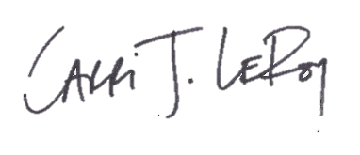
Carri LeRoy, Ph.D.
Director, Master of Environmental Studies Program
leroyc@evergreen.edu

