May 17, 2024

Student ID: A00448185
Dear Laureen,

Congratulations! It is my pleasure to inform you that you have been selected as the recipient of the 2024-2025 Sara Ann Bilezikian Fellowship by the Graduate Program on the Environment at The Evergreen State College. The fellowship is in the amount of $12,795 each year for the 2024-2025 and 2025-2026 academic years. The award will be credited to your student account in three installments each equal to a third of this amount for Fall, Winter and Spring Quarters of both academic years as long as you are enrolled for at least 8 credits as an MES student.

This award reflects the judgment of the selection committee that you have demonstrated an exceptionally strong commitment to environmental improvement and social justice. Sara Ann Bilezikian, who graduated from Evergreen in 2001, had similar interests, and we feel confident that your passions and academic achievement in this area will be a suitable way to honor Sara’s memory.

Please note that adjustments to your aid are likely to occur if there are changes to your status, such as changes to enrollment status, number of credit hours, or residency status. In addition, increased personal resources may result in decreases to other financial aid awards including possible repayment for financial aid you have already received, including loan proceeds.

In order to accept this award, please login to your Award Spring portal and accept the terms and conditions of the award by July 1st, 2024. If you have any questions about this award, please contact the MES office at averi.a.azar@evergreen.edu or 360 742-8746.

Sincerely,
Carri LeRoy

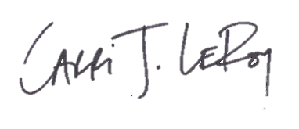
Carri LeRoy, Ph.D.
Director, Master of Environmental Studies Program
leroyc@evergreen.edu

