June 23, 3023

To Whom It May Concern,

I am writing to confirm the current academic progress and academic plan for Joshua Dennis in the Master of Environmental Studies program at The Evergreen State College for the academic years 2022-2023 and 2023-2024. We require a total of 72 quarter credits to earn the MES degree which breaks down to 32 core credits, 24 elective credits, and 16 thesis credits. At present, Joshua is on track to complete all of the first-year core coursework comprised of 24 out of 32 core credits, and half of his required 24 elective credits by the end of Summer 2023. In Fall 2023, at the beginning of the 2023-2024 academic year, Joshua will pursue the final core course, Case Studies and Thesis Design and another 4 elective credits. His final two quarters will include 8 thesis credits in winter and in spring with the option to pursue his final 8 elective credits between Winter and Summer quarters 2024. Joshua’s academic plan for 2023-2024 has been outlined below:
- Fall 2023
  - 8 credits of Case Studies and Thesis Design
  - 4 elective credits
- Winter 2023
  - 8 Thesis credits
  - 4 elective credits
- Spring 2023
  - 8 Thesis credits
  - 4 elective credits with an option to pursue his final 4 elective credits in Summer 2024
Please feel free to reach out with any questions at any time about Joshua’s academic plan in the Master of Environmental Studies Program.

Best wishes,
-Averi

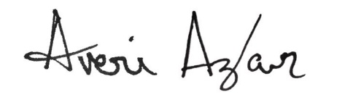

Averi Azar, MES (she/her/hers)
Assistant Director, Master of Environmental Studies
The Evergreen State College, Lab 1 / 3022
averi.a.azar@evergreen.edu
3 6 0. 7 4 2. 8 7 4 6

