October 26, 2018

Kale (Albert) McConathy

820 Eastside St NE

Olympia, WA 98506

Dear Albert, A# A00214828

Congratulations! It is my pleasure to inform you that you have been selected as the recipient of the 2018-19 Randy Ray Memorial Scholarship in the amount of $1000 by the Graduate Program on the Environment at The Evergreen State College. The award will be credited to your student account in three installments each equal to a third of this amount for Fall, Winter and Spring Quarters as long as you are enrolled as a MES student.

This award reflects the judgment of the selection committee that your application materials demonstrate an interest in environmental policy, particularly at the state and local level. Randy Ray, a graduate of the MES program in 1991, dedicated his career to public service in Washington state and we feel confident that your passions and academic achievement in this area will be a suitable way to honor Randy’s memory.

Please note that adjustments to your aid are likely to occur if there are changes to your status, such as changes to enrollment status, number of credit hours, residency status, etc. In addition, increased personal resources may result in decreases to other financial aid awards including possible repayment for financial aid you have already received, including loan proceeds.

In order to accept this award, please email Andrea Martin at [martina@evergreen.edu](mailto:martina@evergreen.edu) indicating your acceptance by November 9, 2018.

If you have any questions about this award, please contact the MES office at 360-867-6225.

If you have any questions about loans or the Evergreen Need Grant, please contact Financial Aid at 360-867-6205.

Sincerely,

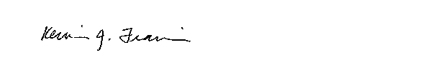

Kevin Francis, Ph.D.

Director, Graduate Program on the Environment

[francisk@evergreen.edu](mailto:francisk@evergreen.edu)

360-867-5831