May 10, 2017

Zeinab Sow

11436 80th Place S

Seattle, WA 98178

Dear Zeinab, A# A00232732

Congratulations! It is my pleasure to inform you that you have been selected to receive the Alumni Association Scholarship from the Graduate Program on the Environment at The Evergreen State College.

This award is a non-renewable scholarship of $1000. The amount will be credited to your student account during Spring Quarter, 2017 as long as you are registered for at least eight MES credits.

Please note that adjustments to your aid are likely to occur if there are changes to your status, such as changes to enrollment status, number of credit hours, residency status, etc. In addition, increased personal resources may result in decreases to other financial aid awards including possible repayment for financial aid you have already received, including loan proceeds.

If you have any questions about this award, please contact the MES office at 360-867-6225.

If you have any questions about loans, please contact Financial Aid at 360-867-6205.

Sincerely,

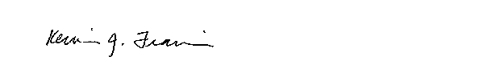

Kevin Francis, Ph.D.

Director, Graduate Program on the Environment

francisk@evergreen.edu

360-867-5831