**MES Adjunct Faculty:**

**About Richard:**

Richard Bigley is a forest ecologist who teaches as adjunct faculty in the Evening and Weekend Studies and Masters of Environmental Studies programs. Richard teaches sustainable forestry and on occasion a forest ecology class.

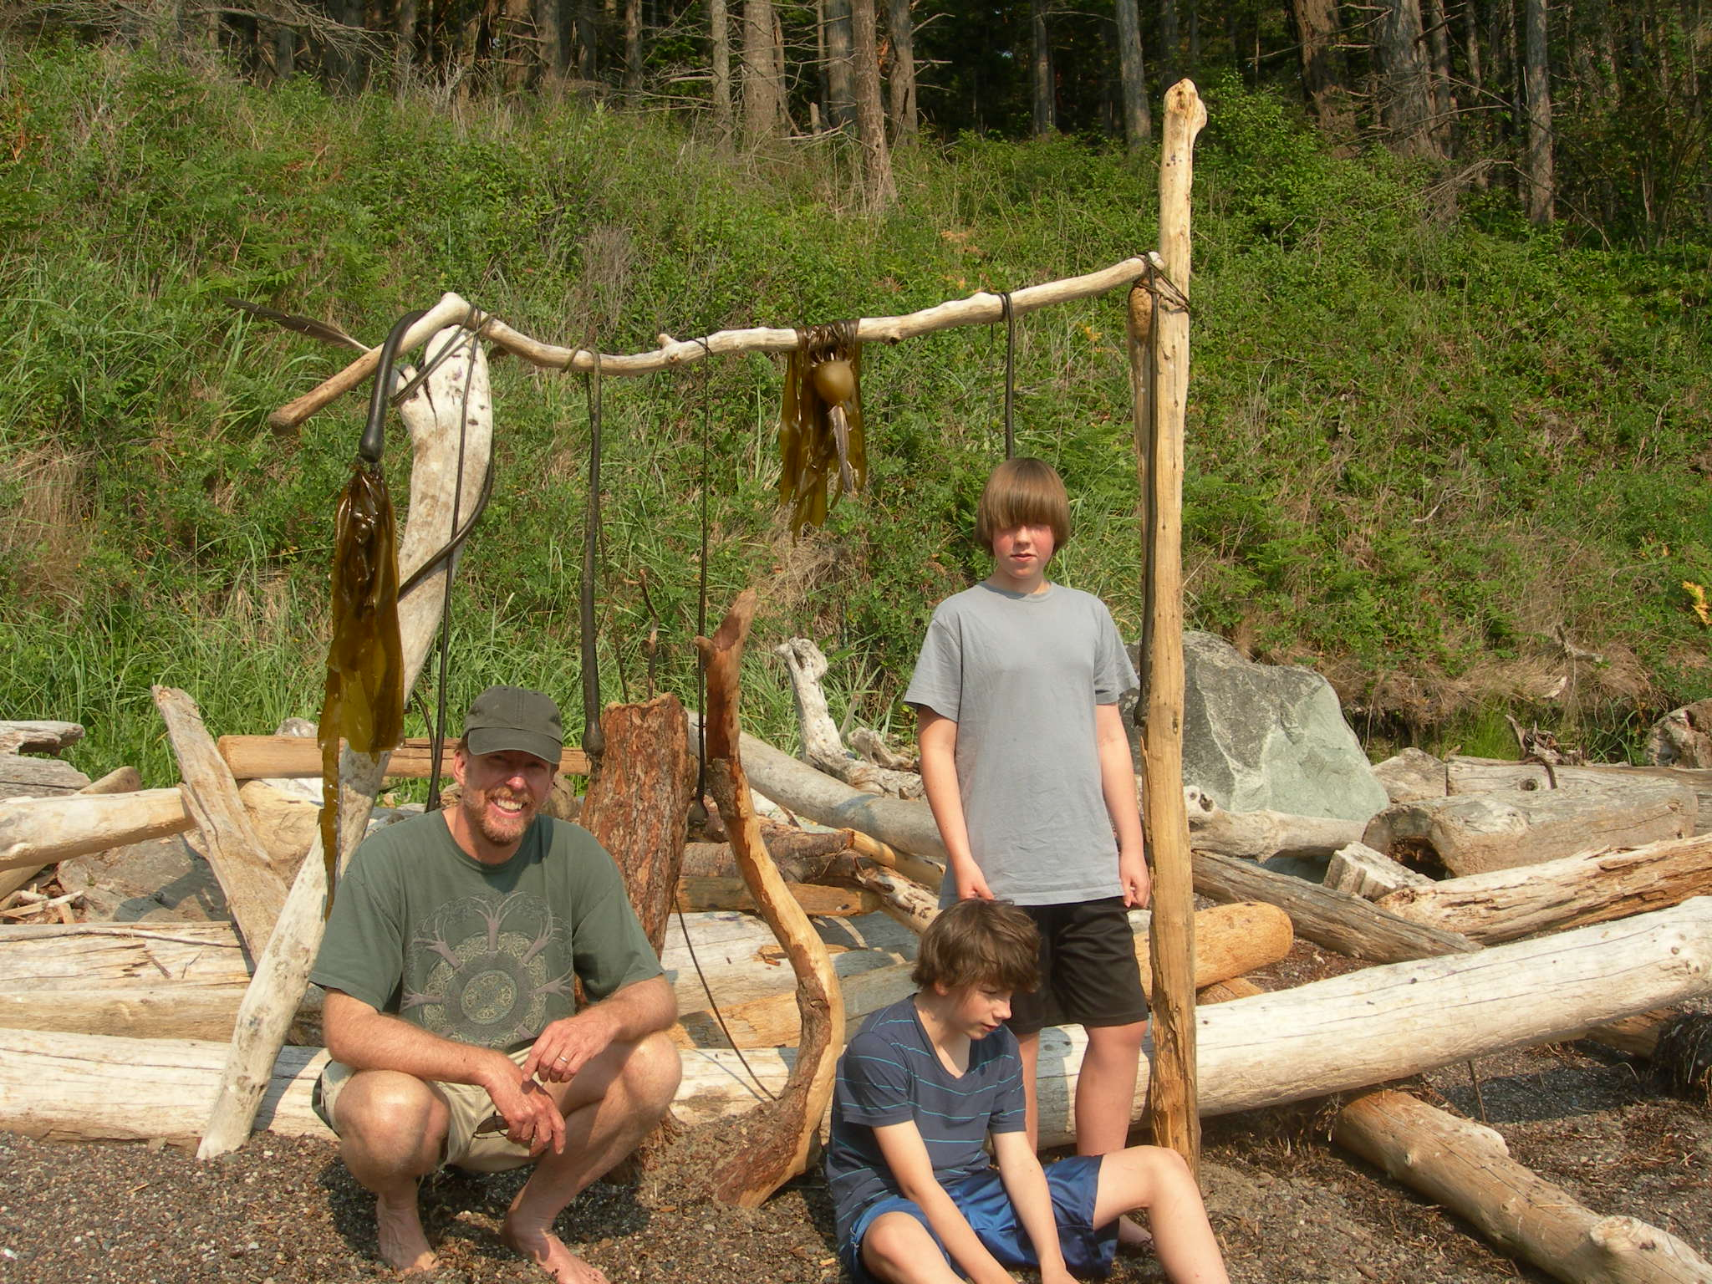

After his family, his passions are the science of natural resources management and conservation, and boating.

His current work focuses on the restoration of riparian forests to older forest conditions in western Washington, and the ecology and management of headwater streams and wetlands. He works for the Washington State Department of Natural Resources in Olympia. Over the last 21 years with DNR, he has served as the team leader for the Forest Ecology, Wildlife Science and the Habitat Conservation Plan Monitoring and Adaptive Management Teams. He also advises other organization on the development of conservation plans. Before joining WADNR, he worked as an ecologist for the Forest Service PNW Experiment Station and private industry.

Richard earned a Ph. D. in Forest Ecology and Silviculture and M Sc. in Botany from the University of British Columbia. He has been an Affiliate Assistant Professor at the University of Washington, College of the Environment, School of Forestry Since 1994. As member of the Northern Spotted owl “5-year review” panel in 2004, Richard was a contributor to the first comprehensive evaluation of the scientific information on the Northern Spotted owl since the time of listing of the as threatened under the Endangered Species Act in 1990.

Contact:

Richard Bigley

[rbigley@evergreen.edu](mailto:rbigley@evergreen.edu)

**Selected Publications**

Pollock M.M., T.J. Beechie, M. Liermann, R.E. Bigley 2009. Stream temperature relationships to forest harvest in western Washington. Journal of the American Water Resources Association 45 (1): 141-156.

Homann P.S., B.T. Bormann, J.R. Boyle, R.L. Darbyshire, R. E. Bigley. 2008. Soil C and N minimum detectable changes and treatment differences in a multi-treatment forest experiment. Forest Ecology and Management 255:1724–1734

Plug L. J., J. C. Gosse, J. J. McIntosh, and R.E. Bigley 2007. Attenuation of cosmic ray flux in temperate forest. Journal of Geophysical Research. 112: F02022 9 pages

Bigley, R.E. and F.U. Deisenhofer. 2006. Implementation Procedures for the Habitat Conservation Plan Riparian Forest Restoration Strategy. WADNR Scientific Support Section, Olympia, Washington. 78p.

Courtney, S. P., J. A. Blakesley, R. E. Bigley, M. L. Cody, J. P. Dumbacher, R. C. Fleischer, A. B. Franklin, J. F. Franklin, R. J. Gutiérrez, J. M. Marzluff, L. Sztukowski. 2004. Scientific evaluation of the status of the Northern spotted owl. Sustainable Ecosystems Institute, Portland, Oregon.

Pollock, M. M., T. J. Beechie, S. Chan, and R.E. Bigley. 2004. Monitoring restoration of riparian forests. In P. Roni, editor. Monitoring stream restoration projects. American Fisheries Society, Bethesda, Maryland.

Bigley, R.E., S.W Hull. 2000. Managing Wetlands. WADNR Scientific Support Section, Olympia, Washington.

Bigley, R.E., S.W Hull. 2000. Recognizing Wetlands. WADNR Scientific Support Section, Olympia, Washington.