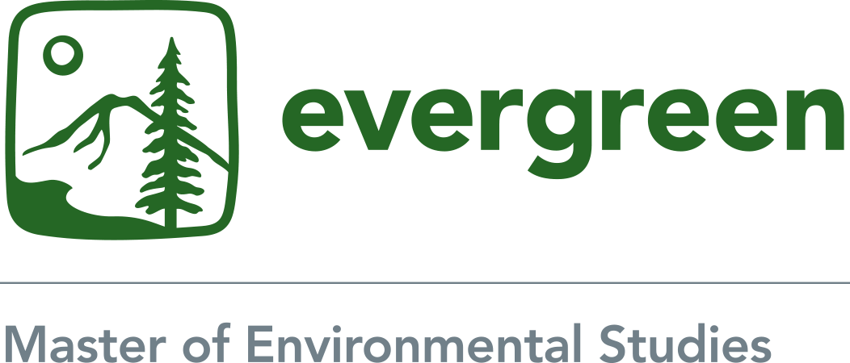

Photograph and Video
Student Permission 2019-2020

At various times throughout the MES Program, photographs or videos may be taken of you during class participation at Evergreen or while you are participating in an internship or field experience in the community. With your permission, the photographs and/or videos may be chosen for college recruitment publications, including the Master in Environmental Studies webpages and/or brochure. If chosen, the photographs and /or videos will be used exclusively by The Evergreen State College and solely for non-profit purposes related to our education program.

Please check one of the following options and provide your signature. If you have any questions, please contact Andrea Martin, Assistant Director of the Master in Environmental Studies program at martina@evergreen.edu or 360-867-6225. Thank you.

Name (please print):

Check one of the following:

- I give my permission for photographs and/or videos taken of me as an MES student to be used by The Evergreen State College for publication purposes.

- I do not give my permission for photographs and/or videos taken of me as an MES student to be used by The Evergreen State College for publication purposes.

Signature:

Date:

