MES Orientation

Agenda, fall 2024

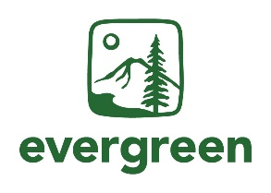Date: September 20th, 2024

**Location:** Evergreen Olympia Campus, SEM II, Room E1105

Or on zoom at: <https://evergreen.zoom.us/j/86493049956>

Time: 8:30am – 4:30pm PST

| Time | Activity | Moderator |
| --- | --- | --- |
| 8:30am | Morning Coffee |  |
| 9:00am | MES Welcome and Program Overview | Averi Azar |
| 9:50am | Break |  |
| 10:00am | DEI Presentation with BIPOC and LGBTQ+ Intersectional Support Services (BLISS) | Juanita Hopkins, Golden Sather, and Averi Azar |
| 11:00am | Break |  |
| 11:15am | gCORE Introduction | gCORE Faculty |
| 11:30pm | Meet your MES Faculty | Carri LeRoy |
| 12:15pm | Faculty Advising First Meeting in Groups | MES Faculty |
| 12:30pm | Lunch |  |
| 1:30pm | **Evergreen Resources:** |  |
| 1:30pm – Student Wellness Services | Eric Frevert |
| 1:45pm – Veterans Resource Center | James Blacklaw |
| 2:00pm – Registration and Records | Leona Walker |
| 2:15pm – Financial Aid | Trina Griffis |
| 2:30pm – Basic Needs Center and Center for Community Based Learning and Action | Rachel Espinoza Ortiz,  V Guardado, Ellen Short-Sanchez |
| 2:45pm – Access Services | Lilly Kinnamon |
|  | 3:00pm – MESA Student Club and Student Activities | Tyrone Cawston and  Nat Kelly |
| 3:15pm | Break |  |
| 3:30pm | Current Student Panel – Q&A | Zoe Ortega with Current Students |
| 4:30pm | Closing Announcements & Reminders | Averi Azar |