Dear Fall 2012 MES cohort member:

Welcome to the 29th cohort of the Graduate Program on the Environment at The Evergreen State College! This is your formal invitation to the **required MES orientation on Saturday, Sept 15, 8am-5pm.** Please read below for further instructions about the day.

**Read *Silent Spring***

As your first academic exercise as an MES student, you will be discussing the book *Silent Spring* by Rachel Carson in small seminars with individual core faculty. Please read the book prior to orientation. Any edition of the book, new or used, is acceptable.

Rachel Carson was a marine biologist, writer, and conservationist who wrote the ground-breaking *Silent Spring* in 1962, an analysis of chemical pesticides’ harmful effects on birds and humans. The book’s highly controversial message was widely read by the US public and led to US government investigation into her findings. These efforts resulted in a US-ban on DDT and other pesticides as well as the creation of the US Environmental Protection Agency (sadly, both happened after her death). Because of Ms. Carson’s important role in the modern-day environmental protection movement, she is honored every year by the Master of Environmental Studies Student Association (MESA) through the Rachel Carson Forum, now entering its 24th year. The Graduate Program on the Environment and its close to 600 graduates owes a large debt to Ms. Carson’s commitment to and concern of the world around us.

**Where to Meet**

Meet in the Seminar II Building, Room A1105.  Seminar II is just to the right of the “grassy knoll” on the enclosed campus map. Parking is free on Saturdays and Intercity Transit buses #41 and #48 go to Evergreen.

**Agenda**

The tentative schedule is included in this packet.  Orientation is a mandatory event—it is a “one-stop-shop” for all your MES questions and also a taste of the academic experience you will have over your two or more years with us. You will also get to meet most of the faculty and staff, and some returning students. Lunch, snacks, coffee, and tea will be provided; please bring your own refillable water bottle and coffee mug. Finally, come prepared to get your individual picture taken.

We’re putting a lot of work into the program, and are looking forward to meeting all of you.  Should you find, due to unavoidable circumstances, that you are unable to attend orientation, it will be your responsibility to let us know you won’t be there and to obtain the information on your own after the 15th.  We will have a folder of information for you in the MES office to start you off, but because it will be a very busy part of the year, we will not be able to provide you with a personal orientation.  Please remember that MES is a professional program, and our expectation is that you treat its curriculum, your classmates, and MES staff and faculty as you would your employer and coworkers.

**Preparing for gCORE**

Your first core class at Evergreen is entitled graduate Conceptualizing Our Regional Environment, or gCORE. This course is taught by three faculty: Carri LeRoy, Kevin Francis, and Martha Henderson. Please see the enclosed faculty biographies for more information on their backgrounds and interests. You will meet them at orientation, as well as the other core and adjunct faculty. At orientation, we will go over the gCORE syllabus with you. Please mark your calendars for an overnight field trip on October 18-19 and a shorter field trip in the afternoon of September 27. There will be an additional course fee of $100 for these trips that will be assessed with your tuition. The first class meeting is Tuesday, September 25 at 6pm-10pm, room TBA. Prior to class, you are invited to a “Welcome Back” reception for all MES students at 5pm near the MES office. More details to come.

**Required Texts**

For all courses, including gCORE, faculty will let you know which books are required – they will usually announce them by email or you can check the Greener Store’s website: [www.tescbookstore.com](http://www.tescbookstore.com). Books can be purchased from any bookstore, including the Greener Store. The Greener Store also rents books or you can check them out from the Evergreen Library through interlibrary loan.

**Immunizations**

You should have received information regarding Evergreen’s policy requiring proof of Measles (Rubeola) immunity for all new students. Students who do not submit proof by the end of Fall quarter will not be able to enroll for Winter quarter courses. Please see [www.evergreen.edu/health/health/immunizations](http://www.evergreen.edu/health/health/immunizations).

**Explanation of Terms**

You may notice that in some places we say “Master of Environmental Studies” and in others we say “Graduate Program on the Environment.” The Graduate Program on the Environment grants students a Master of Environmental Studies (MES) degree upon graduation. We often refer to the program as “MES.”

We also have “core” faculty and “adjunct” faculty. Core faculty teach in core classes and some electives and adjunct faculty teach electives only. Core faculty are typically full-time Evergreen faculty who teach only in MES. The entire cohort of 40-45 students attends core classes together on Tuesday and Thursday evenings. Classes are taught by teams of two or three faculty that then split into smaller seminar groups. Adjunct faculty typically have full-time jobs in the community for state agencies and teach one elective a year for MES. Electives are one night a week (Monday or Wednesday) and are taught by one faculty member. Electives are usually 15 students.

You’ll also grow accustomed to the word “seminar.” Seminars are integral to the Evergreen teaching philosophy. They are forums of approximately 15 students in which issues are raised and explored, but not necessarily resolved; they require you to think and to practice the skills of analysis and synthesis. In each core class, you will be assigned a smaller seminar group with one individual faculty. Please see the enclosed “What are Seminars?” handout for more information.

**United Way Day of Caring**

On Friday, September 21, please consider joining other MES students for a community volunteer project in the afternoon (1-5pm). We will have more information at orientation.

**Questions?**

Please contact Gail Wootan, Assistant Director, at 360-867-6225 or [wootang@evergreen.edu](mailto:wootang@evergreen.edu).

Sincerely,

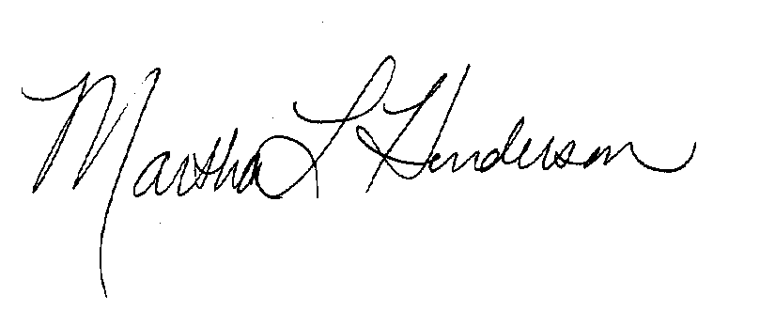

Martha L Henderson, Ph.D.

Director, Graduate Program on the Environment