Master of Environmental Studies
Hooding Ceremony
Graduation Celebration
The House of Welcome
June 12, 2024

5:30 pm to 7:00 pm
Catered Dinner

7:00 pm to 8:30 pm
Ceremony

Welcome
Carri LeRoy, Ph.D.
MES Director

Opening Remarks
Dexter Gordon, Ph.D.
Evergreen Executive Vice President

Faculty Speaker
Kathleen Saul, Ph.D.

Session 1 12:00-12:50
Session 2 1:00-1:50

Keynote Speaker
Pah-tu E. Pitt, MES
(Confederated Tribes of Warm Springs, Wasco, Yakama, and Pitt River (Wintu))
Co-Owner of Native Kut, LLC.
Vice-Chair and Commissioner, Columbia River Gorge Commission
Lecturer, University of Washington-Tacoma

Hooding of the Graduates

Sessions Descriptions

Surfing the Waves of Change: (Hugh ONeill and Yonit Yogev)
Founded in 1984, the Graduate Program on the Environment awards a Master of Environmental Studies degree. The program is internationally known for its commitment to student learning grounded in critical thinking and creative possibilities to solve environmental problems from an interdisciplinary perspective. The program emphasizes environmental issues and opportunities in the Pacific

This may be beneficial to you, as we learned that we will be experiencing a major system upgrade sometime around the first of June. So as no to delay your decision, please try and meet the deadlines above.

Graduate Program on the Environment

Founded in 1984, the Graduate Program on the Environment awards a Master of Environmental Studies degree. The program is internationally known for its commitment to student learning grounded in critical thinking and creative possibilities to solve environmental problems from an interdisciplinary perspective. The program emphasizes environmental issues and opportunities in the Pacific Northwest. Students understand broader ecological, economic, political, social, and cultural impacts of a single environmental issue. Students are encouraged to show professional leadership, communication, and research skills necessary to address current environmental challenges. With more than 1000 graduates, alumni can be found across local, state, federal, and tribal governments, as well as corporations, and nonprofit organizations, serving communities to inspire lasting environmental and social change.

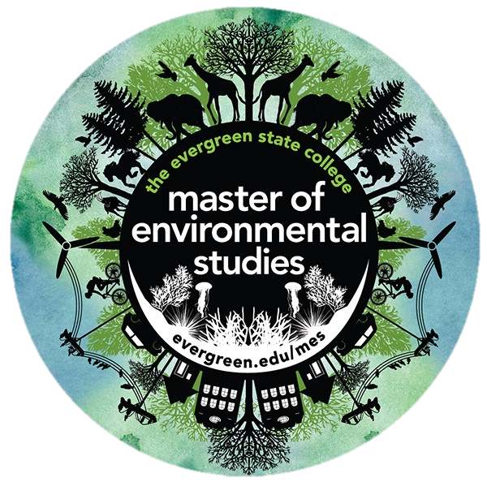

Acknowledgements

Special thanks to the Evergreen Staff who helped make
this event possible: Media Services Staff, Catering Staff,
Communications Building Staff, Marketing Staff, Graduation Office Staff and Facilities Staff. We so appreciate all of you and the many ways you have supported this celebration of our graduates!

Main Commencement begins promptly at
1:00 pm on June 14!

Graduates: Please pick up a Graduation Check-in card and write your
name, phonetic pronunciation, and pronouns for the graduate readers
prior to walking at the main commencement ceremony.

Please find your MES staff at 12:45 pm to line up for
Main Commencement on June 14 between Purce Hall and Lab 1.

Guests: Please proceed to Guest Seating
in Red Square on June 14 for Main Commencement

