MES Admitted

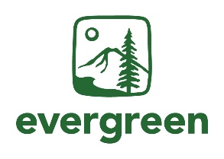student day Agenda

Date: April 25th, 2025

Time: 9:00am – 4:30pm (PT)

**Location:** Purce Hall, Classroom 7

Zoom option: <https://evergreen.zoom.us/j/83945769275>

The Evergreen State College, Olympia Campus

| Time | Sessions | Facilitator |
| --- | --- | --- |
| 9:00am | Coffee and light refreshments |  |
| 9:30am | MES Director Welcome and Introductions | Carri LeRoy |
| 9:45am | Program Overview | Averi Azar |
| 10:45am | Break |  |
| 11:00am | Faculty Introductions and Panel | MES Faculty |
| 12:15pm | Sustainability in Prisons Project Introduction | SPP Staff |
| 12:30pm | Lunch and optional forest walk to the Organic Farm |  |
| 2:00pm | GIS and Drone Certificates Talk | Mike Ruth |
| 2:45pm | Current Student Panel | Averi Azar with  Current MES Students |
| 3:45pm | Closing Announcements & Reminders | Averi Azar |
| 4:00pm | Averi available for questions until 4:30 pm |  |

Additional Community Events

**Thursday, April 24** – Rachel Carson Forum event put on by the MESA student club

**Friday, April 25** - Attend Luminary for Arts Walk in Olympia, WA

**Saturday, April 26** – Arts Walk and Procession of the Species parade in downtown Olympia & MES 40th Anniversary Celebration Event at Evergreen, Purce Hall, 10am-2pm

You can also email Averi Azar at averi.a.azar@evergreen.edu to request the link to register for the Admitted Student Day.