MES Admitted

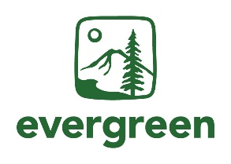student day Agenda

Date: April 26th, 2024

Time: 9:00am – 4:00pm (PT)

**Location:** Purce Hall, Classroom 7

The Evergreen State College, Olympia Campus

| Time | Sessions | Facilitator |
| --- | --- | --- |
| 9:00am | Coffee and light refreshments |  |
| 9:30am | MES Director Welcome and Introductions | Carri LeRoy |
| 9:45am | Program Overview | Averi Azar |
| 10:45am | Break |  |
| 11:00am | Faculty Introductions and Panel | MES Faculty |
| 12:15pm | Sustainability in Prisons Project Introduction | SPP Staff |
| 12:30pm | Lunch with Faculty |  |
| 2:00pm | GIS and Drone Certificates Talk | Mike Ruth |
| 2:45pm | Current Student Panel | Averi Azar with  Current MES Students |
| 3:45pm | Closing Announcements & Reminders | Averi Azar |
|  |  |  |

Additional Community Events After Admit Day

**Friday, April 26 at 8:00pm** - Attend Luminary for Arts Walk in Olympia, WA. Meet MES staff on Legion and Capitol if you would like to join us as a group.

**Saturday, April 27** – Arts Walk and Procession of the Species parade in downtown Olympia

**Friday, May 2** – Rachel Carson Forum event put on by the MESA student club

You can also email Averi Azar at averi.a.azar@evergreen.edu to request the link to register for the Admitted Student Day event if you have not already done so.