**MES Admitted Student Afternoon | Thursday, April 24, 2pm-6:30pm  
Rachel Carson Forum to follow  
Register at www.evergreen.edu/mes/admits**

Students admitted to the Graduate Program on the Environment for Fall 2014 are invited to attend our Admitted Student Afternoon on Thursday, April 24, as well as our student-organized Rachel Carson Forum – this year’s theme is local solutions to climate change. Students are encouraged to stay through Friday and beyond to explore the Olympia area and learn more about Evergreen. The yearly Procession of the Species is on Saturday - join in on this quirky Earth Day-related Olympia tradition (started by Eli Sterling, MES '91) that has spread around the world! [Learn more](http://en.wikipedia.org/wiki/Procession_of_the_Species) about Procession at http://procession.org.

Housing is provided Thursday evening for a limited number of students on a first come, first served basis in on-campus apartments. Attendees may choose to stay extra nights on campus for an additional cost or for free with current students. Parking will also be provided on Thursday and Friday (parking is free on weekends).

**Registration**

Please register for free at www.evergreen.edu/mes/admits or by calling 360-867-6225 by April 18, 2014.

**Schedule (subject to change)**

**Thursday, April 24 – Seminar 2 Building, Room A1107 (see www.evergreen.edu/tour/docs/areamap.pdf)**

|  |  |
| --- | --- |
| **2:00PM - 3:00PM** | Afternoon Welcome: Hosted by Director and Assistant Director (coffee and tea provided) |
| **3:00PM - 4:00PM** | MES Faculty Panel with Q&A |
| **4:00PM - 5:00PM** | Current student thesis and internship presentations |
| **5:00PM - 6:30PM** | Alumni panel with dinner (provided) |
| **7:00PM - 9:00PM** | Rachel Carson Forum (optional), hosted by the Master of Environmental Studies Association (MESA), FREE |
|  |  |

**Friday, April 25**

|  |  |
| --- | --- |
| **11:00AM - 2:00PM** | Organic Farm and Evergreen beach tour (bring a lunch or lunch money), FREE |
| **11:00AM - 12:30PM** | Campus tour, Admissions office, Library Building |
| **2:30PM - 4:00PM** | Campus tour, Admissions office, Library Building |
| **5:00PM - 10:00PM** | Olympia Arts Walk, Downtown Olympia, FREE |
| **9:30PM** | Luminary Procession (part of Procession of the Species), Downtown Olympia, FREE |

**Saturday, April 26**

|  |  |
| --- | --- |
| **2:00PM - 8:00PM** | Olympia Arts Walk, Downtown Olympia, FREE |
| **4:30PM** | Procession of the Species, Downtown Olympia, FREE |

**Sunday, April 27**

|  |  |
| --- | --- |
| **ALL DAY** | Explore Olympia, Mt. Rainier, Seattle, Olympic National Park, or the Puget Sound! |

**Housing**

MES can provide a limited number of rooms in on-campus apartments on Thursday night for students who need it (first come, first served basis).  You can request housing when you register. If you would like to stay on campus additional nights, you are responsible for the additional nights at $30 per night. If you have a tight budget, we also offer the option of staying with an MES student for free. Please indicate your preference when registering. If you would prefer to stay at a hotel or B&B, here are some lodging suggestions:

**Lodging Suggestions (ask if they have an Evergreen discount):** www.visitolympia.com/lodging **Olympia Air B&B:** www.airbnb.com/s/Olympia--WA

**Getting Here**

For those flying to Olympia, the closest airport is the Seattle-Tacoma airport (SEATAC).  You can rent a car, take the Capital Aeroporter shuttle (www.capair.com), or take [public transit](http://tripplanner.kingcounty.gov/cgi-bin/itin_page.pl?resptype=U) to Olympia (use tripplanner.kingcounty.gov to plan your trip from SEATAC to Olympia Transit Center and then take [Intercity Transit](http://www.intercitytransit.com/Pages/default.aspx) bus #41 or #48 to Evergreen). Please see www.evergreen.edu/tour/docs/areamap.pdf for driving directions and a campus map.

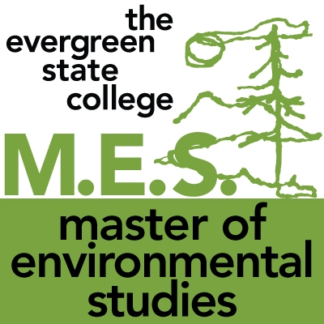

We look forward to meeting you!