In Memoriam

Carolyn Dobbs

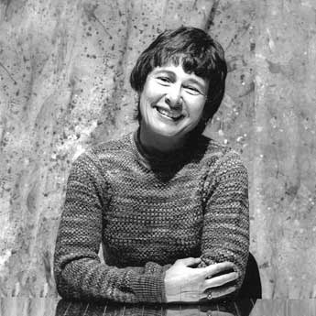

Jeff Cederholm

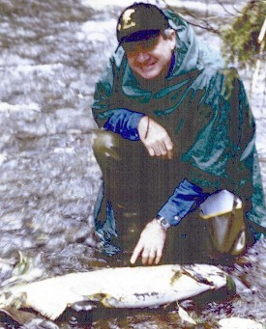

Jovana & Bill Brown

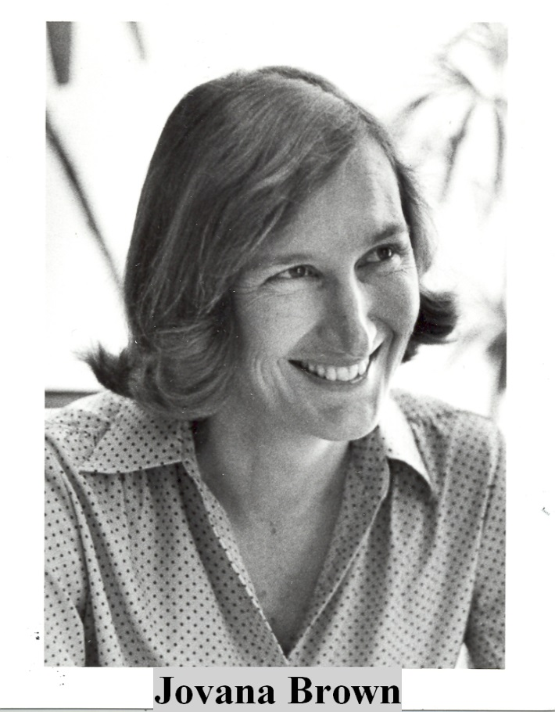

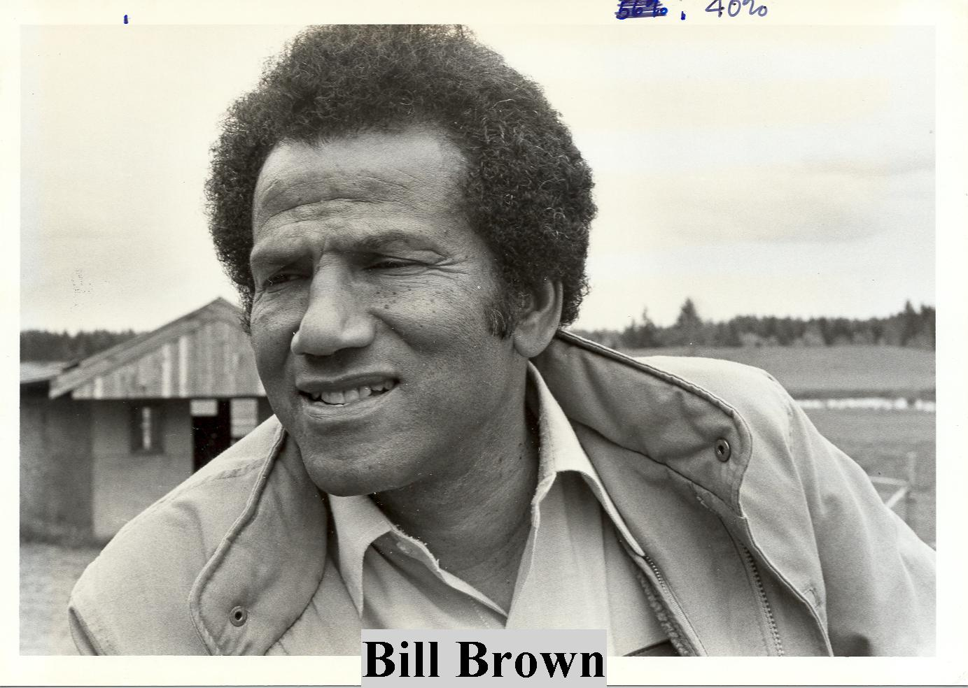

Bob Sluss:

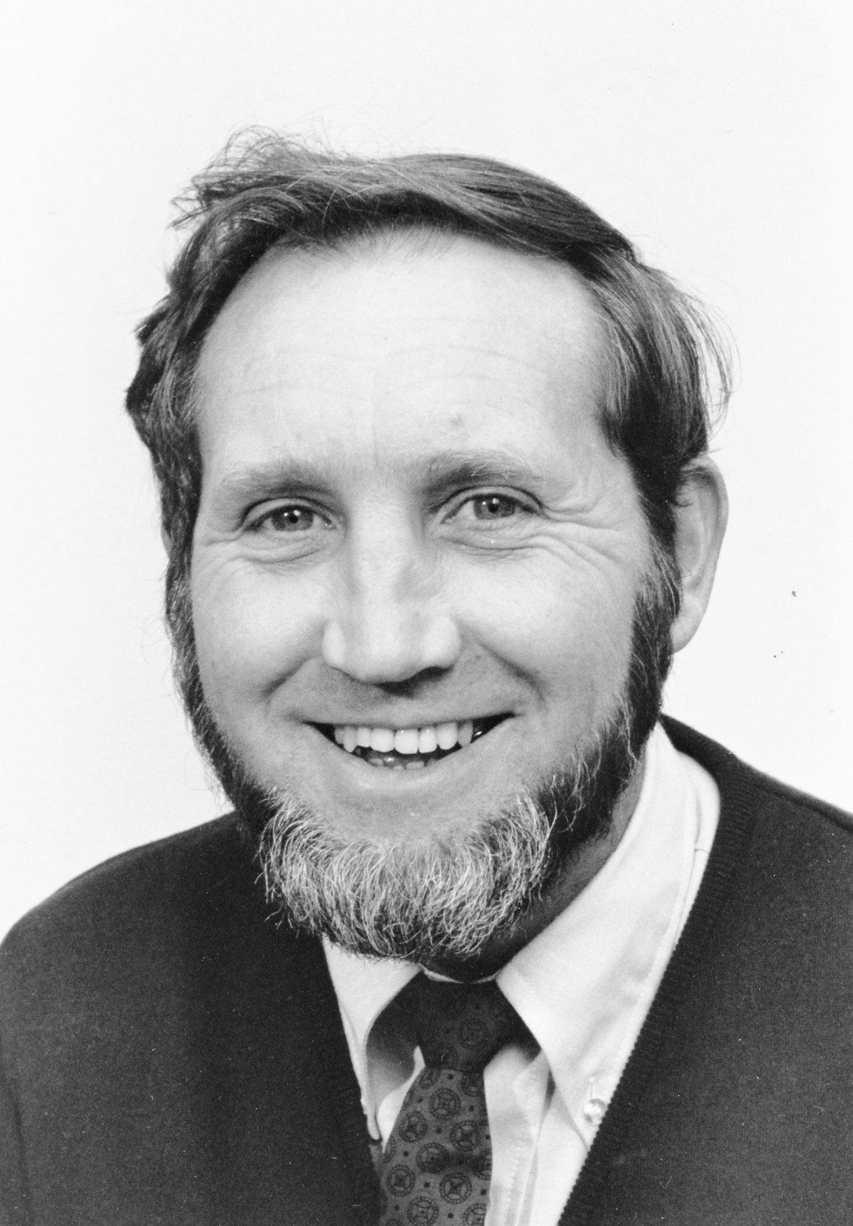

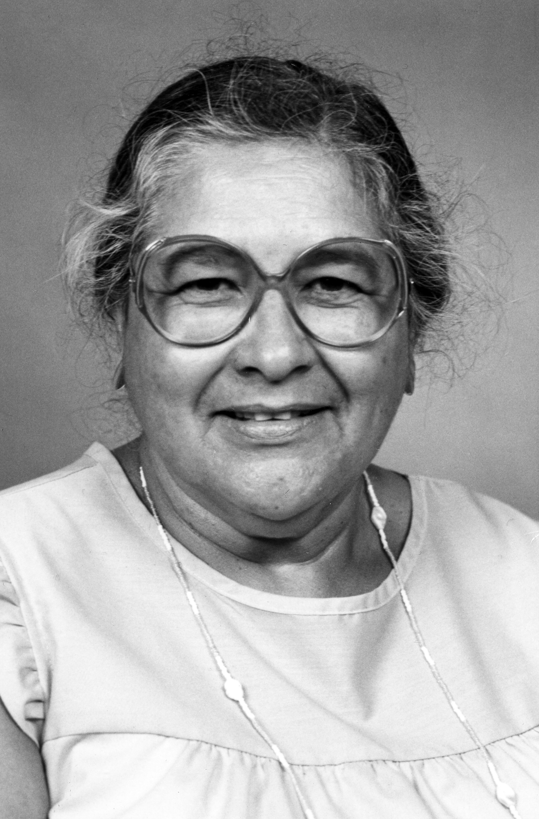

Staff: Bonnie Evans (use one of these. The small one cannot be enlarged)

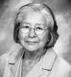

Alumni (this only includes people who graduated. I know for a fact there are some who were MES students that didn’t graduate who have passed away)

|  |  |  |
| --- | --- | --- |
| first | last | cohort |
| Andrew | McMillan | Fall 1995 |
| Janet | Benke | Fall 1985 |
| LeEllyn | Burnett | Fall 2002 |
| Robert | Keith | Fall 1987 |
| Jeffrey | Leigh | Fall 1988 |
| Ralph | Mason | Fall 1986 |
| Ann | Tyler | Fall 1987 |