The Promises and Pitfalls of Clean Energy – Syllabus
Winter 2016

Faculty: Kathleen Saul, Lab I 2026, 360-867- 6511, saulk@evergreen.edu
Class times: Wed. 6 – 10 pm., Jan. 6 through March 9, 2016
Sem 2, Room E3107

Description
In a perfect world it would be easy to develop energy sources to replace fossil fuels that most people would describe as clean, renewable, and “good.” In reality, it’s not so simple. As one example, the U.S. Environmental Protection Agency considers hydropower to be a clean, renewable energy resource since it relies on the earth’s natural water cycle to generate electricity. But large-scale hydroelectric dams have also earned a dubious reputation in the Pacific Northwest for their impact on salmon habitat and Native American fisheries. This elective will explore the many faces of clean/renewable energy. It will begin with an overview of technologies such as solar, wind, nuclear, and others that have been proposed as alternatives to fossil fuels. It will examine their benefits and disadvantages from a number of perspectives: technical, economic, environmental, political, social, and cultural. By the end of the course, students should better understand the complex nature of energy technologies and decisions regarding their use.
Objectives
1. To introduce students to the basic terminology associated with electricity and its generation and with renewable energy resources.
2. To understand the connections between climate change mitigation and renewable energy usage.
3. To gain a deeper appreciation for the challenges of transitioning to a renewable energy future: changes in energy resources for electricity production will have technical, political, social, and cultural ramifications.

Course Format
The course will combine faculty lectures with films, guest presentations, and class discussions of current issues in renewable energy generation in its social, ecological, political, and economic contexts.

Assignments
News Articles – At least once during the quarter, each student must bring a renewable energy-related article to share with the class. The article should have been published within the last three – four months (since the beginning of the academic year). The student will need to provide an oral summary of the contents of the article and suggest how it relates to the contents of the course.

Class Project– Stabilization wedges
- First introduced by Princeton University’s Drs. Socolow and Hotinski in 2007
- Looks at the projected emissions for the “business as usual” scenario and the flat, stabilization scenario
- Divides the triangle formed by those two lines into eight wedges
- Of what should those wedges be composed to bring the business as usual line into congruence with the stabilization line?

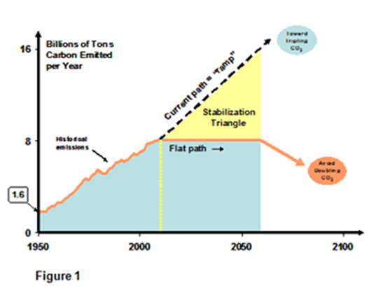

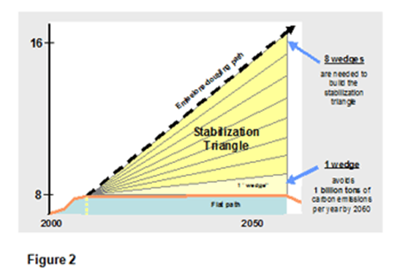
Source: http://cmi.princeton.edu/wedges/intro.php

Readings
All class readings will be posted on the Canvas site at least one week ahead of the due date.
Books for Those Seeking Additional Information

The Basics:
Brox, Jane. (2010) Brilliant: The Evolution of Artificial Light. New York, NY: Houghton Mifflin.

Chambers, Ann. (1999) Power Primer: A Nontechnical Guide from Generation to End Use. Tulsa, OK: Pennwell Books.

On Fracking:
Bamberger, M. and R. Oswald. (2014) The Real Cost of Fracking: How America’s Shale Gas Boom is Threatening our Families, Pets, and Food. Boston, MA: Beacon Press.

Gold, Russell. (2014) The Boom: How Fracking Ignited the American Energy Revolution and Changed the World. New York, NY: Simon and Schuster.

On Policy:
Graetz, Michael. (2013) The End of Energy: The Unmaking of America’s Environment, Security, and Independence. Cambridge, MA: MIT Press.

Inslee, Jay, and Bracken Hendricks. (2008) Apollo’s Fire: Igniting America’s Clean Energy Economy. Washington, D.C.: Island Press.

Rinfret, Sara R. and Michelle C. Pautz. (2014) U.S. Environmental Policy in Action: Practice and Implementation. New York, NY: Palgrave MacMillan.

Things Nuclear:
Alexievich, Svetlana. (2006) Voices from Chernobyl: The Oral History of a Nuclear Disaster. New York, NY: Picador. (Translated from the Russian by Keith Gessen)

Brown, Kate. (2013) Plutopia: Nuclear Families, Atomic Cities, and the Great Soviet and American Plutonium Disasters. New York, NY: Oxford University Press. (Compares Hanford and a similar complex in the Soviet Urals)

Cohen, Steven Mark. (1997) Too Cheap to Meter: AN Economic and Philosophical Analysis of the Nuclear Dream. Albany, NY: State University of New York Press.

Ehrlich, Gretel. (2013) Facing the Wave: A Journey in the Wake of the Tsunami. New York, NY: Pantheon. (Fukushima)

Medvedev, Zhores. (1990) The Legacy of Chernobyl. New York: W. W. Norton & Co.

Walker, J. Samuel. (2004) Three Mile Island: A Nuclear Crisis in Historical Perspective. Berkeley, CA: University of California Press.

Misc.
Byrne, John and Young-Doo Wang, eds. (2014) Green Energy Economies. New Brunswick, NJ: Transaction Publishers.

Dixon, John A. et al. (1994) Economic Analysis of Environmental Impacts. New York, NY: Routledge.

Yergin, Daniel. (2012) The Quest: Energy, Security, and the Remaking of the Modern World. New York, NY: Penguin Books.

Credit and Evaluation
- Partial credit is not awarded in the MES Program.
- Full credit will be awarded based upon attendance, punctuality, participation in class discussions, and timely submission of the final assignment.
- To be excused due to illness, religious or work obligation, family emergency, conference attendance, or the like, contact your instructor as soon as possible. Depending upon the reason, you may or may not be excused.
- Credit will be jeopardized if there are unexcused absences, a pattern of tardiness, lack of participation on a regular basis, or failure to submit the final assignment, or evidence of plagiarism of any or all of that assignment.
- All students are required to participate in an evaluation conference with their seminar instructor during the 11th week, bringing with them a draft self-evaluation and a faculty evaluation or entering these online prior to the evaluation so that faculty can see they are completed.
- Alternatively, the faculty evaluation may be submitted to Program Secretary Pam Udovich (Lab I 1020), for her to keep until after the faculty member has filed the student evaluation.
Detailed Weekly Schedule
Week | Date | Activity | Reading
1 | Jan 6 | The Basics: Introductions, review of syllabus  What is clean energy?  Overview of units of energy and electricity  What came out of UNFCCC COP-21, Paris, Dec. 2015?  Introduction to “wedges” and the final project
2 | Jan 13 | NO CLASS  Please attend Climate Change Research and Action in Washington State event:  10:00 am – 2:00 pm Longhouse  2:30 pm – 5:00 pm Recital Hall, COM Building  See http://www.evergreen.edu/sustainability/climatejan2016 | Chambers (quick history); Taminiau & Byrne (polycentric approach); Bill Gates on Clean Energy
3 | Jan 20 | Characterizing Energy Technologies: Life Cycle Analysis, Levelized Cost  Natural Gas: A bridge to renewables? | “Getting to 100” Report; Sander & Murthy; Schleisner; Wang, Wu & Huo; Lazard; Selections from Gold
4 | Jan 27 | Natural Gas cont’d.  Policy Tools: Renewable Portfolio Standards (RPS), Feed in Tariffs (FIT), Tax Incentives, Loan Subsidies | Wing & Jin; IEA report on policy considerations; Rizzi, van Eck, & Frey;  Optional Reading: Wustenhagen & Menichetti (public investments); Hu et al (dynamic pricing)
5 | Feb 3 | Nuclear: Is it clean, green? | Stigka, Paravantis, & Mihalakakou (public acceptance of renewables)  TISS Social Impact Assessment Report
6 | Feb 10 | Solar/Wind | Hernandez et al.; Margonelli; Byrne et al. (solar cities); Muller et al.; Bergmann, Colombo & Hanley (wind in Scotland)
7 | Feb 17 | Role of Smart Grid Technology  Biomass/Biofuel | Ellabban,Abu-Rub, & Blaabjerg; Horn & Stein
8 | Feb 24 | Other
9 | Mar 3 | Clean Energy in China: Myth or Realty? | Qi, Zhang & Karplus; Lo (policy review); Hu et al.; Yergin chapter
10 | Mar 10 | Stabilization Wedge presentations | “Now Comes the Tough Part”
 | Mar 14 - 18 | Evaluation Week

