***Restoration Ecology*** Fall 2015

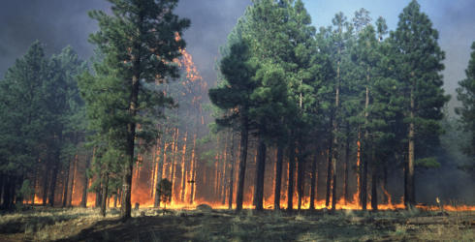

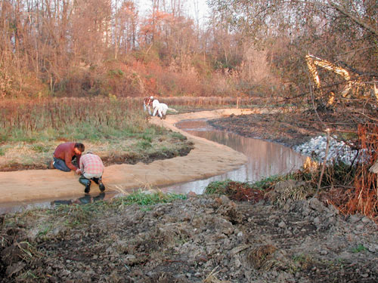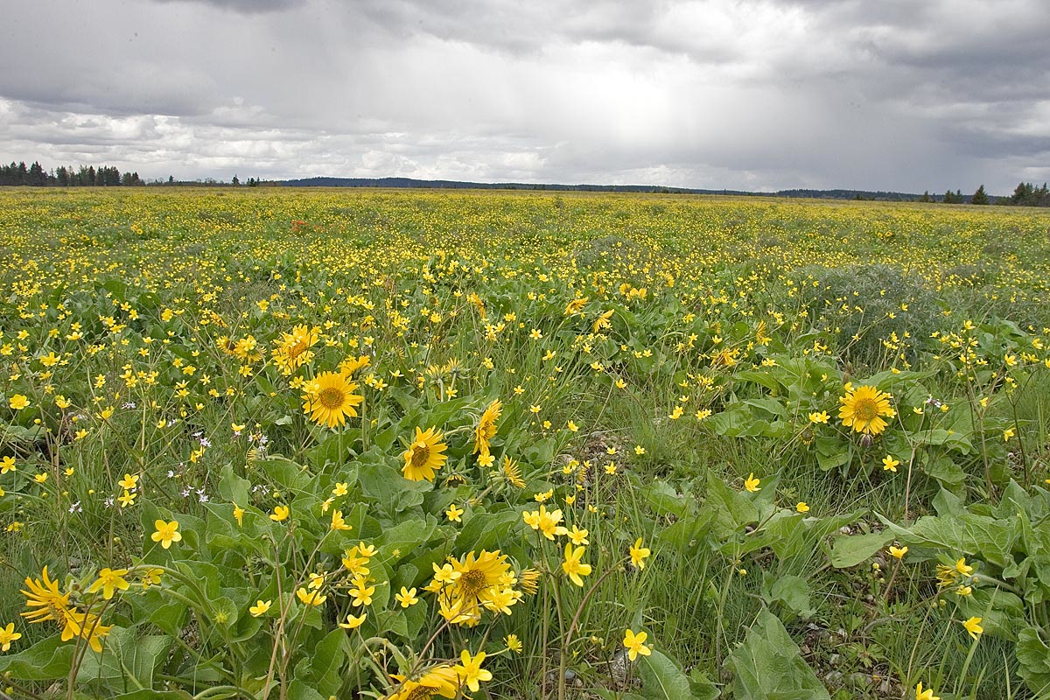

**Course Description: *Restoration Ecology*** is a 4 credit MES program elective offered Fall 2015. The field of restoration ecology is fairly young, relative to other scientific disciplines. However, ecological restoration has occurred throughout human history, as various cultures have initially disrupted and then attempted to recover vital ecosystem services provided by intact, functioning ecosystems. Identifying priority restoration targets for nearly any ecosystem is one of the largest challenges for the conservation community, as it requires a complex understanding of the historical, social, political and ecological influences on restoration success.

This 4 credit graduate level course will explore both the objective and the subjective facets of restoration ecology, including various cultural perspectives on the value of restoration, how economic and political realities influence restoration targets, and the integrated structural and functional components of ecosystems that contribute to the success or failure of any restoration project. Students will have the opportunity to evaluate several large-scale restoration projects throughout the world and take part in active ecological restoration here in the Pacific Northwest.

“Here is the means to end the great extinction spasm. The next century will, I believe, be the era of restoration in ecology.” – E.O. Wilson

**Instructor:** Sarah Hamman |360.790.4180| hammans@evergreen.edu

**Class resources via Canvas** [https://canvas.evergreen.edu/courses/407](https://webmail.evergreen.edu/owa/redir.aspx?C=bigPyRBPykmsgzrzzeq5ZRARQ6uz_NEIWrCwxNHL90344q462KmUQetoE5ScqXRqWeq_O__5jeA.&URL=https%3a%2f%2fcanvas.evergreen.edu%2fcourses%2f407)***.*** PDF versions of class materials, including presentations, articles, etc. will be posted on the website. There is one text to purchase: Leopold, A. 1949. *A Sand County Almanac*. Oxford University Press, New York, NY.  This book has been published by several companies and is available in most libraries and bookstores.

**Class Meetings:**

*Lectures***: Monday evenings from 18:00 to 22:00** SEM II E2107

**Field Trips:**

Friday, November 6 1700- Sunday, November 8, 1700 Elwha Dam Removal Restoration

**Be prepared for field work on field trips:**

This class emphasizes field-based, hands-on experience with ecology and ecosystem analysis, which requires traveling off trail in potentially rough conditions. You need to be properly attired and have the proper equipment. Please come prepared for spending the day outside. This includes wearing sturdy shoes and long pants (shorts and sandals stay in the van), maintaining your metabolism (food and water), and protecting yourself from the environment (**rain gear**, sun protection, etc.). Please care for yourself and know your limits in all weather. Safety on field trips is a shared responsibility. Take it seriously. Each field trip will begin with a safety briefing.

**ATTENDANCE/CREDIT**:  
Attendance at lectures, discussions, and field trips is REQUIRED. Absence from class without alternate arrangements is noted in evaluations. If you miss more than two class sessions without prior arrangements you will lose credit.

**ASSIGNMENTS/EVALUATION:** I will use four areas to evaluate your progress toward course goals: participation and contribution to the class, effective communication, literature review and final presentation. These activities will help you synthesize salient information and provide the opportunity to practice speaking in a safe environment.

1. **Participation and contribution to the class:** Each of us brings something to the class, whether it is information, experience, insights or thoughtful questions. Make the best contribution you can. Remain objective.
2. **Effective communication:** During class each student will be responsible for reporting material from the text and primary literature relating to restoration ecology and natural resource management. Each student will be required to lead discussion and submit summaries of the readings once. Please share the work with your seminar partners so you are all contributing equally to discussion.
3. **Literature review:** A key component of any scientific discipline is a familiarity with the primary literature. Evaluation will include outline, draft and final versions of a literature review surrounding a restoration case study.
4. **Final presentation:** Each student will be required to give an oral presentation to the class on a restoration project case study and the associated literature. Evaluation will involve the presentation itself and any supporting materials.

**CLASS SCHEDULE**

|  |  |
| --- | --- |
| Week/lecture subject | Readings/ Activities |
| ***Week 1 – Sept 28th***  Class expectations; Introduction to restoration ecology; history and development of discipline; ecological concepts |  |
| ***Week 2 – Oct 5th***  NO CLASS | Assignment: Young et al. (2005), Suding (2011)  A Sand County Almanac pgs 3-25.  **DUE:** 1-2pg summary (single spaced) of Suding article with examples of 1) Convergence, 2) Unintended Divergence and 3) Deviating Trajectories |
| ***Week 3 – Oct 12th***  Development of restoration targets; identifying reference conditions | Assignment: Thorpe and Stanley (2011), Jackson and Hobbs (2009)  A Sand County Almanac pgs. 25-98 |
| ***Week 4 – Oct 19th***  Novel ecosystems; Restoration project design and implementation | Assignment: Hobbs et al. (2009); Seastedt et al. (2008); Murcia et al. (2014)  A Sand County Almanac pgs. 101-129  Choose topic for literature review and presentation |
| ***Week 5 – Oct 26th***  Trophic interactions; soils in restoration | Assignment: Harris (2009), Ripple and Beschta (2012); Epanchin et al. (2010)  Assignment: A Sand County Almanac pgs. 130-173;  Develop outline for literature review |
| ***Week 6 – Nov 2nd***  Riparian restoration; Elwha Dam removal (guest lecture); Field trip logistics | Additional reading – Duda et al. (2008), Pess et al. (2008), Witze (2015)  Assignment: A Sand County Almanac pgs. 177-202;  Field trip to Elwha Dam removal site, Olympic National Park Nov 6-8;  **DUE:** Outline of literature review |
| ***Week 7- Nov 9th***  Restoring ecosystem services | Daily and Matson (2008); Ruckelshaus et al. (2015)  A Sand County Almanac pgs. 202-233 |
| ***Week 8 – Nov 16rd***  Restoration in a changing climate; planning for the future | Assignment: Bradley et al. (2009), Choi (2007); Lawler and Olden (2011)  A Sand County Almanac pgs. 237-264  **DUE:** 1st draft of literature review |
| ***Quarter break – Nov 23rd***  NO CLASS – Thanksgiving |  |
| ***Week 9 – Nov 30th***  Political, social and economic realities of restoration projects | Assignment: Assignment: Garibaldi and Turner (2004); Chazdon et al. (2009); Monaco et al. (2012)  A Sand County Almanac pgs. 264-295 |
| ***Week 10 – Dec 7th***  Final student presentations | **DUE:** Final draft of literature review |
| ***Eval week - Dec 14th – 18th*** | Evaluation conferences will include a short written self and faculty evaluation |