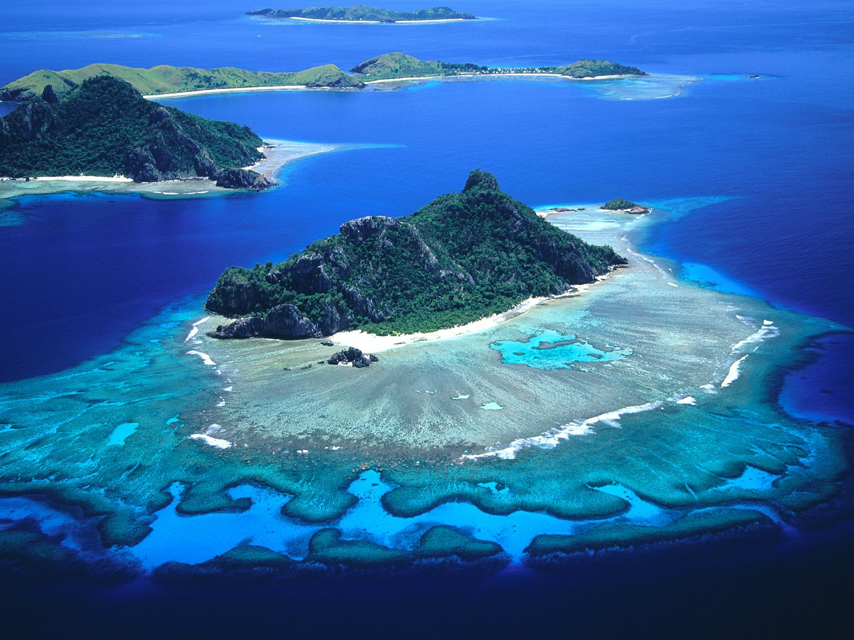

Climate Change and Sustainability in the  
**F I J I**  
I s l a n d s  
S u m m e r Q u a r t e r / A u g u s t 2 0 1 4

**Join** MES for an international learning experience in the Republic of Fiji from **August 3-20, 2014**, and **earn 2 or 4 graduate credits** while exploring a beautiful and intriguing country on the forefront of climate-change adaptation.

**Investigate** climate impacts such as coral bleaching, threats to mangroves and other nearshore ecosystems, rising sea levels, and declining terrestrial biodiversity, including the loss of important endemic species.

**Learn** how the Fijian government, NGOs, and everyday people address the effects of climate change; from adaptation activities at a local level to lobbying the international community through regional partnerships with other Small Island Developing States (SIDS).

**Visit** coastal and inland villages, government offices, NGOs, and the University of the South Pacific (USP), where villagers, policymakers, advocates, activists, and scientists address challenges related to island biodiversity, geography, political economy, and community development.

**Lend a hand** to two conservation and restoration service projects alongside local NGOs, **snorkel** on healthy and degraded reefs, and **sleep and eat** in rural villages for an immersive experience alongside Fijians and expatriates working on community development initiatives.

**Choose your adventure** by providing faculty with input on what you want to learn, see, and do in Fiji.

Previous international travel experience is not necessary, but students must be patient, flexible, and prepared for plans to change on short notice.  The trip will include travel to remote areas and camp-like sleeping situations. Students must have a passport valid **through** **March 2015** and should know how to swim. Total approximate cost including air travel from LAX, program fee, lodging, and transportation is **$3,150** (not including tuition for 2 or 4 graduate credits). First deposit ($500) due May 1.

For more information about credit, costs, and itinerary, visit the MES Course Catalog or email Brittany Gallagher at [gallagher.brittany@gmail.com](mailto:gallagher.brittany@gmail.com).