***Fire Science and Society*** Spring 2012

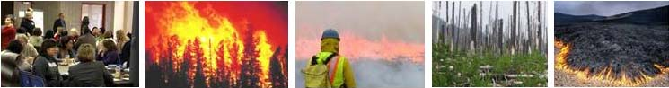

**Course Description: *Fire Science and Society*** is a 4 credit MES program elective offered Spring 2012. Undergraduates enrolment is possible only week 1 if space is available. E-mail bigleyr@evergreen.edu to be on the wait-list.

Fire has plays the role of ecosystem engineer in forests and grasslands throughout the world. This role has changed over the past hundred years, however, with increasing human populations, sprawling development into fire-prone areas, and altered perceptions of this vital ecological process. With fire suppression and exclusion, we are seeing dramatic changes in the structure and functioning of fire-influenced ecosystems and the role of fire in natural resources management and policy.

There are significant ecological, social and political implications of these changes, ranging from the listing of fire-adapted endangered species to more rigorous air quality regulations to altered pressures and priorities for the timber industry. Adapting policies in the anticipation to climate change has become a major priority. It is becoming more important for citizens to understand both the benefits and the risks associated with fire as it is increasingly impacting people in their daily lives.

This course will introduce students to the language, the ecology and the politics surrounding wildland fire and increase your effectiveness with opportunities that involve fire science, application and management.

**Instructors:** Sarah Hamman | shamman@cnlm.org & Richard Bigley | [bigleyr@evergreen.edu](mailto:bigleyr@evergreen.edu)

A class fee $125 to cover multiple day field trip expenses is required, any unused portion will be refunded

There is one text to purchase: *Living with Fire: Fire ecology and policy for the 21st century*, 2008 by Sara E. Jensen and Guy R. McPherson

**Class Meetings:** *Lectures***: Monday evenings from 18:00 to 22:00** Sem 2 D2109

**Class schedule for the first 3 week:**

Week 1 Monday April 2 No class

Week 2 Monday April 9 **Class** 6pm

Week 3 Monday April 16 **Class** 6pm, and Wednesday April 18th **Field trip** to a Fire conference

Advance warning

Week 7 Required Field trip May 18-19-20, Friday 0600- Sunday 1500, camping near Wenatchee