April 15, 2016

Sarah Vansot

Department of Natural Resources

Olympia, WA

Dear Ms. Vansot:

This letter is to inform you that Emily Moore is currently in her first year of the Master of Environmental Studies degree at The Evergreen State College, and is in good academic standing. She will continue the program, at least half-time, until her expected graduation date of June 2017.

Sincerely,

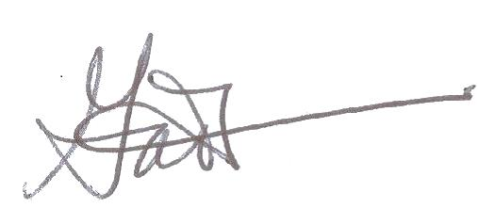

Gail Wootan, M.Ed.

Assistant Director