June 25, 2024

To Whom It May Concern,

This letter is intended to act as official confirmation from the Master of Environmental Studies Program at The Evergreen State College that Cody Seehaver has completed the MES degree and has expressed an interest in pursuing the new Drone Certificate at Evergreen to further his environmental career. Cody’s interest in the Drone Certificate aligns well with recent advancements of GIS and Drone technology in the environmental sector, as these technology resources have been increasingly implemented for restoration and conservation management practices. Drone technology continues to be an asset for environmental work as it allows a habitat to receive a greater scale of assessment from aerial footage rather than the traditional on-the-ground human surveys. As a result, plant and animal species studied for the purpose of land management, conservation, or restoration, will be better monitored in the environmental field. The knowledge of Drone flying and mapping, as well as it’s integration with GIS software, is an important skill environmental professionals will be asked to gain if they wish to further their careers in this field.

At the time that Cody was a student in our program, we did not yet offer the Drone Certificate at Evergreen State and so he did not have an opportunity to gain this skill or certificate. Cody has since expressed interest in this certificate, and as his former graduate program, we wholeheartedly support his desire to pursue the Drone Certificate for further career development in the environmental sector.

If you have any questions, please contact me at leroyc@evergreen.edu.

Sincerely,
Carri LeRoy

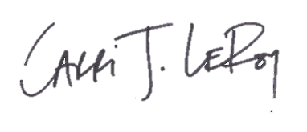
Carri LeRoy, Ph.D.
Director, Master of Environmental Studies Program
leroyc@evergreen.edu

