August 22, 2024

To Whom It May Concern,

This letter is intended to act as official confirmation from the Master of Environmental Studies Program at The Evergreen State College that Ander Pierce has fulfilled all requirements for the MES Degree. Our Program has provided confirmation to the Registration and Records office at Evergreen to confer their MES on his transcript. The Registration and Records office will need time to post his degree to their transcript but please accept this letter as confirmation of degree earned status until it can be officially posted to Ander’s transcript.

If you have any questions, please contact me at leroyc@evergreen.edu.

Sincerely,
Carri LeRoy

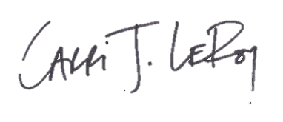
Carri LeRoy, Ph.D.
Director, Master of Environmental Studies Program
leroyc@evergreen.edu

