March 18, 2025

«name_first» «name_last»
Student ID: «Column1»

Dear «name_first»,

I am pleased to inform you that you have advanced to candidacy standing in the Master of Environmental Studies program. The faculty have made this decision based on the quality of your work in the first two core programs during Fall and Winter quarters, 2024-2025.

Congratulations! This significant achievement reflects that you have succeeded in graduate-level academic work and that the faculty believes in your ability to complete a substantive research thesis. With candidacy you may continue the core sequence and elective coursework.

We look forward to your future efforts and your successful completion of this degree.

Sincerely,
Carri LeRoy

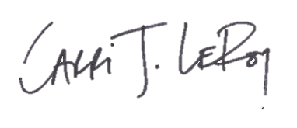
Carri LeRoy, Ph.D.
Director, Master of Environmental Studies Program
leroyc@evergreen.edu

