April 3, 2023

«first_name» «last_name»

**Student ID: «id»**

Dear «first_name»,

I am pleased to inform you that you have advanced to candidacy standing in the Master of Environmental Studies program. The faculty have made this decision based on the quality of your work in the first two core programs during Fall and Winter quarters, 2022-2023.

Congratulations! This significant achievement reflects that you have succeeded in graduate-level academic work and that the faculty believes in your ability to complete a substantive research thesis. With candidacy you may continue the core sequence and elective coursework.

We look forward to your future efforts and your successful completion of this degree.

Sincerely,

Kevin Francis

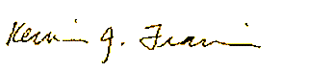

Kevin Francis, Ph.D.

Director, Master of Environmental Studies Program

francisk@evergreen.edu

360-867-5831