

|  |  |
| --- | --- |
| Master of Environmental Studies  Advising |  |
| A holistic advising approach for faculty in MES to support students in their academic and career pursuits as they navigate life in graduate school.  June, 2022 |  |

|  |  |
| --- | --- |
|  | Holistic AdvisingHolistic advising involves curiosity and willingness to engage all aspects of the student’s life experience (<https://nacada.ksu.edu/Resources/Academic-AdvisingToday/View-Articles/Holistic-Advising.aspx>). It also means not only being invested in understanding the whole of a student’s life, but also understanding how to provide support for a student’s whole development. Advisors do not need to be experts in everything but just need to be well versed in referring students to appropriate resources or experts who can support them. Advisors in this way, act as a bridge to eliminate barriers to interpersonal relations building such as students feeling unable to reach out to an office on campus they may not have accessed in the past for support. A referral or personal contact from Advisor to the student support systems allow for greater accessibility and provide the student with a sense of a larger community. The intent of holistic advising is to focus on the whole student, their experiences in academic, professional, and personal settings and how these may influence their success in class.Faculty Advising A Faculty Advisor is a faculty member whose role is to support students assigned to their caseload through their educational progress in the Master of Environmental Studies program. In this role, faculty hold a high authority, high connectedness position in relation to the students they are advising. In the advising role, faculty will still maintain authority on details of academic requirements in curriculum while establishing and maintaining trust with the advisee. Connectedness with students is essential so that roadblocks can be foreseen and students feel comfortable approaching their faculty advisor when problems arise either in their academic or personal lives. In this dynamic, faculty are able to support students in their exploration of opportunities that may arise while they are in MES that would help them explore their academic and career interests to further their goals overall. |
| “A holistic advising approach allows advisors to be comfortable holding in-depth conversations with advisees, which establishes roles of trust and allows advisors to effectively refer students to available resources.”  – Stacey M. Kardash |

|  |  |  |
| --- | --- | --- |
| Asking Questions Asking questions in the Faculty Advisor role is integral to helping establish the relationship, especially in the beginning. Your questions can often start out open ended to provide context for the students but allow for the student to open up about areas they would like to discuss. Some of the defining characteristics of good questions in the advising process are:  **Rapport-building** - Early and ongoing emphasis on building trusting relationships with students. Attentiveness to how changes in the relationship may be indicating changes in the student’s progress.  Strengths focus – Emphasizing strengths and assets over weaknesses, shortcomings, and risk.  Questioning – Posing powerful, focused questions to stimulate active thinking about past experiences and future possibilities.  Envisioning – Actively exploring the desired future, both short and long term. Adjusting that vision together as needed.  Critical thinking – Helping the student weigh the costs, benefits, and realistic outcomes of courses of action before making decisions. | |  |
| Meandering River Flow |  |  |



|  |  |  |
| --- | --- | --- |
|  |  |  |
| *Asking open-ended questions is a way to begin to develop the relationship, with an aim to develop a shared sense of responsibility for the student’s goals. Through holistic advising, advisors work to identify areas of stress or barriers—such as family issues or isolation—that students may face, but they may not link to their academic performance (S.M. Kardash, 2020, Hamline University, 2018).* |  |  |

Questions may change, and likely should change from quarter to quarter. The minimum requirement for each student in the advising caseload, will be to have an appointment with their Faculty Advisor once per quarter in order to maintain connectivity and establish the grounds for focused support and relationship building. Students may elect to meet more frequently if the support from their faculty is meaningful and helpful to their journeys.

# First Quarter Questions

Questions during the first quarter will be focused on relationship establishment and building a raport. The main goal to let the students know about from the beginning is that we want to make sure that the transition students experience into graduate school is smooth, and elevate any immediate barriers that they may be concerned about and discuss addressing them through questions:

*What brought you to the MES program?*

*What are some of your interests currently?*

*What are you interested in pursuing academically right now?*

*Do you have a professional goal you would like to fulfill at this time?*

*What are you hoping to get out of the program?*

*What type of support do you hope to receive from your me, your Faculty Advisor?*

*Do you prefer more frequent meetings than once per quarter?*

*Are there any aspects of graduate school or the MES Program that you are concerned about?*

# Mid-First Quarter Questions

*How has this quarter been for you so far?*

Follow up: *What is your group project focused on?*

*Are you experiencing any challenges accessing the materials you need to participate in class assignments and activities?*

*Have your concerns changed from our last meeting? Ex: Last time you talked about feelings of not being ready for graduate school, are these feelings still present?*

*What is on your mind today?*

*Is there anything you would like to follow up with in particular from our last meeting?*

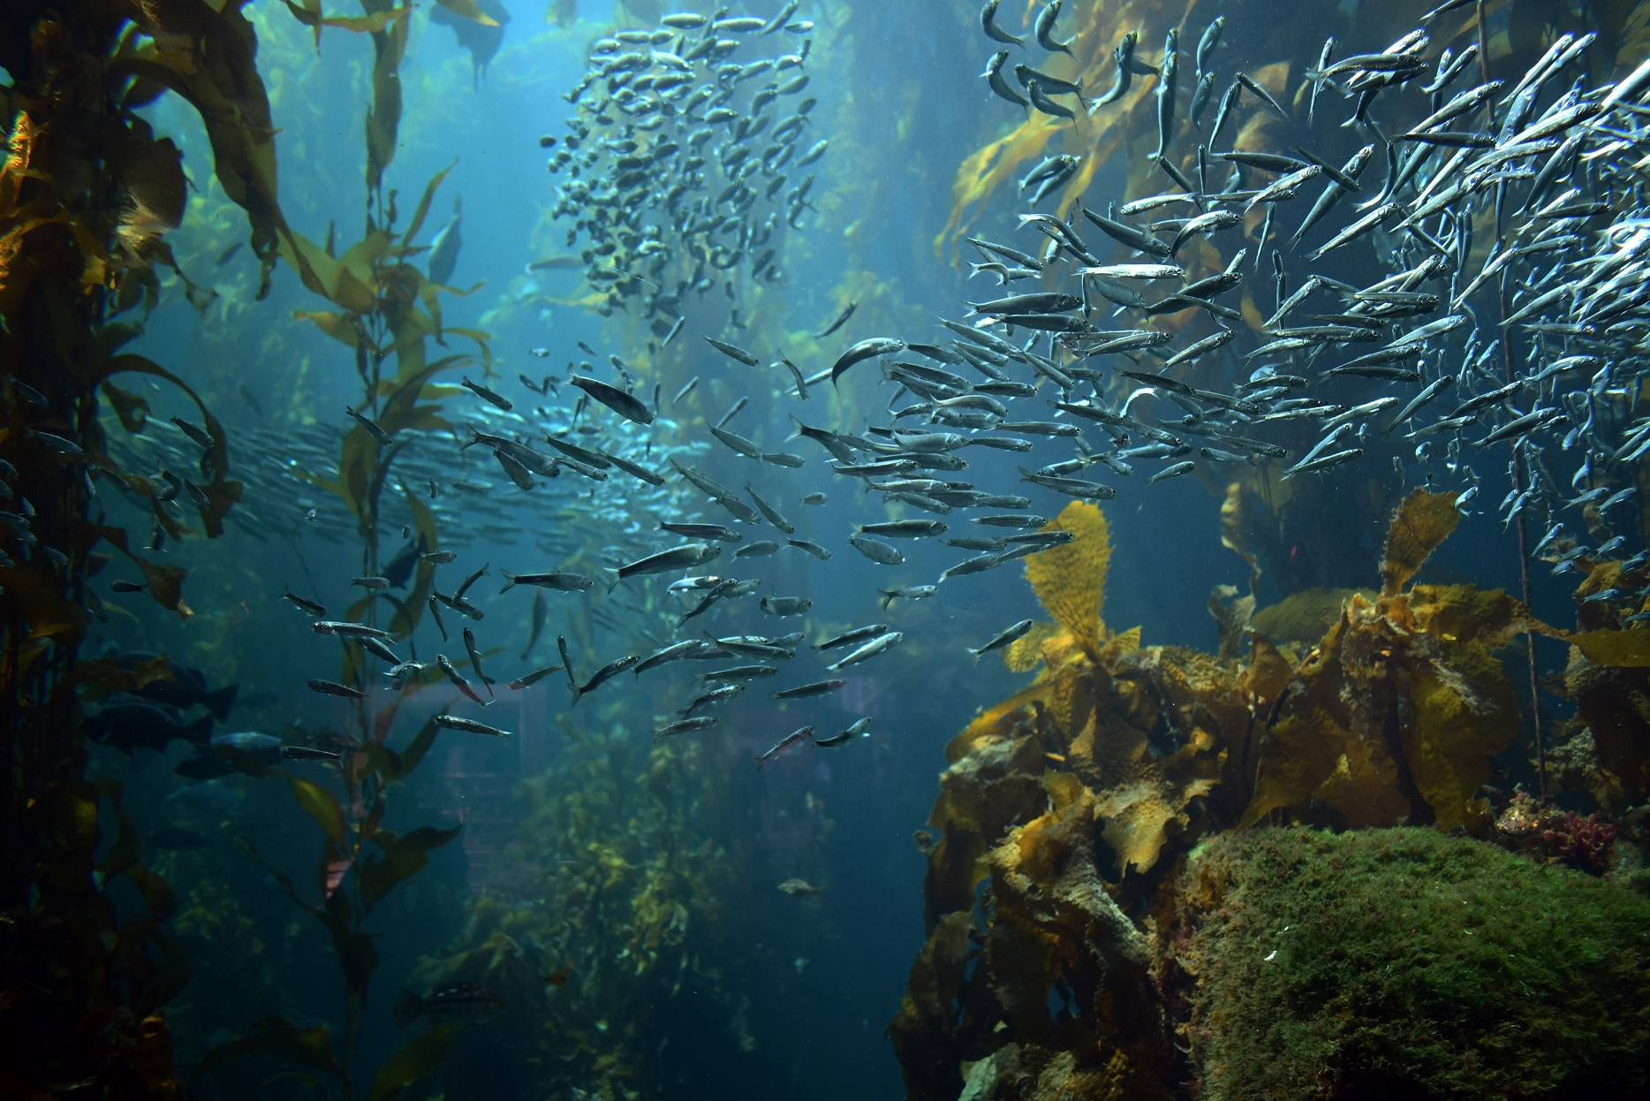

|  |  |  |
| --- | --- | --- |
|  | Top view of a plant |  |
|  | “Faculty advisers’ core job is to help students plan their schedules, be successful in their course work, and prepare for their careers. But professors… know that the role also entails being a first responder to family tragedies, mental illness, substance abuse, learning disabilities, relationship struggles, and other problems. That has been especially true as depression and anxiety rates among college students have [risen sharply.](https://www.chronicle.com/article/An-Epidemic-of-Anguish/232721)” – Alexander Kafka Campus Resources When conversations arise that require the additional support of external support systems at the college, please refer students to these offices or reach out directly if you are unsure who best to refer them to:  Averi Azar  Assistant Director, Master of Environmental Studies  360 742-8746 / [averi.a.azar@evergreen.edu](mailto:averi.a.azar@evergreen.edu)  Campus and Community Resources: <https://www.evergreen.edu/health/resources-crisis-and-emergencies>  Submit a CARE Team Report: <https://www.evergreen.edu/care/care-campus-assessment-response-evaluation-team> | |
|  |  |  |