March 10, 2014

FIRST LAST **NEW STUDENT ID: ANUMBER**

ADDRESS

CITY, STATE ZIP

Dear FIRST,

Congratulations! I am pleased to inform you, upon recommendation by the Graduate Program on the Environment Admissions Committee, that you have been accepted into the Fall 2014 cohort for the Master of Environmental Studies (MES) degree at The Evergreen State College. I hope you are able to join us!

To celebrate your admission to the program, I would like to invite you to the MES Admitted Student Afternoon on April 24, 2014, 2pm-6:30pm. This is your chance to meet faculty, alumni, and students and learn about the opportunities available to you now that you are an MES student. Housing and parking will be provided for those who need it. We have included the schedule of events in this letter. We also invite you to stay afterward for the Rachel Carson Forum, a yearly environmentally-focused event planned by MES students. This year, the focus is on local solutions to climate change. More information and registration instructions are at [www.evergreen.edu/mes/admits](http://www.evergreen.edu/mes/admits). We encourage you to stay for the weekend to discover Evergreen and Olympia!

Important notifications from the college and MES will be sent to your Evergreen email address periodically, so be sure to set it up immediately (directions enclosed) and check it regularly. MES will be sending information shortly about summer and fall paid internships as well as jobs available for MES students. Please also keep your mailing address updated by contacting Admissions: [admissions@evergreen.edu](mailto:admissions@evergreen.edu) or 360-867-6170.

As a new MES student, you are required to enroll in the first MES core class: graduate Conceptualizing our Regional Environment, or gCORE. All core courses are on Tuesdays and Thursdays, 6pm-10pm. If you intend to finish in two years, you should also take an elective course along with gCORE. To see more information on our courses, including faculty contact information, please review the MES online catalog at [www.evergreen.edu/catalog/2014-15/mes](http://www.evergreen.edu/catalog/2014-15/mes). Fall registration instructions will come by email from the MES office sometime in May or June. You may also take summer 2014 courses with MES as a non-matriculated student (including a course to Fiji in August)—these courses will count toward your degree. To see the summer courses offered, go to [www.evergreen.edu/catalog/2013-14/mes](http://www.evergreen.edu/catalog/2013-14/mes).

This year, the Fall quarter starts September 29, 2014. We will hold a mandatory orientation on September 19-20. All new students are required to participate. In mid-August, we will send more specific information to your Evergreen email about orientation if you have accepted this offer of admission.

If you applied for MES aid by March 1, you will receive a separate email notifying you of your MES financial aid award by mid-March. Loan information will be sent to you by the Financial Aid office and will come later. If you did not apply for aid or did not fill out your FAFSA, you can still be eligible for loans and possibly tuition waivers (if funds are available) by filling out your FAFSA at any time. Go to [www.fafsa.ed.gov](http://www.fafsa.ed.gov) to apply.

If you wish to accept this offer of admission, please promptly inform Gail Wootan, the Graduate Program on the Environment Assistant Director, in writing by emailing [wootang@evergreen.edu](mailto:wootang@evergreen.edu). Enclosed is a billing form for your tuition deposit. This non-refundable $100.00 deposit reserves your space in the program. In order to hold your space at the institution **the college must receive payment by May 2, 2014**. If you cannot accept this offer of admission, please notify us in writing immediately.

We’re looking forward to having you join us. It is with considerable care that we select this class of forty-five students. We hope this opportunity to participate in our program will be meaningful to you. You will be part of a diverse, capable, and dedicated group of people. I will be pleased to discuss any aspect of the program with you should you have further questions. The MES faculty and staff look forward to having you join us in September.

Sincerely,

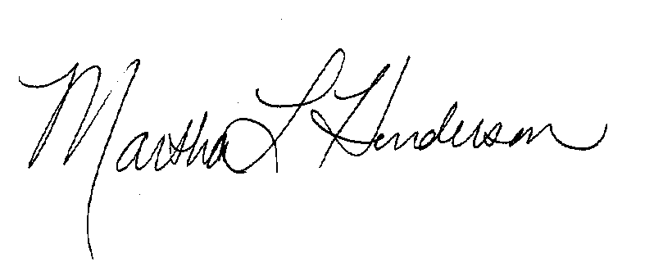  
Martha L Henderson, Ph.D.

Director, Graduate Program on the Environment

(360) 867-6841

mhenders@evergreen.edu