July 25, 2013

Lauren Gingerella

19 Beach Street

Westerly, RI 02891-2702

Dear Lauren: A#: A00337328

Thank you for applying for the Graduate Program on the Environment at The Evergreen State College for Fall 2013. Because you did not pay your tuition deposit or confirm you are joining MES by the deadline outlined in your admission letter, your admission and any financial aid offered is rescinded and will be given to someone on the waitlist.

If you think this letter is sent in error, please call Gail Wootan at 360-867-6225 or email [wootang@evergreen.edu](mailto:wootang@evergreen.edu).

Sincerely,

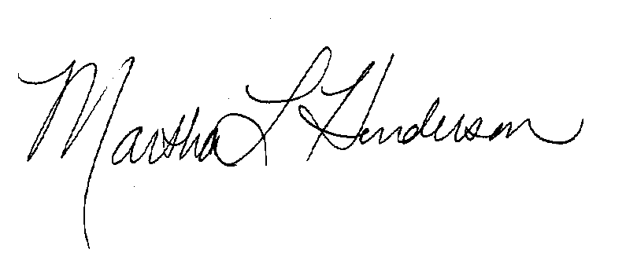  
Martha L Henderson, Ph.D.

Director, Graduate Program on the Environment

(360) 867-6841

mhenders@evergreen.edu