July 3, 2013

FIRST LAST **NEW STUDENT ID: ANUMBER**

ADDRESS

CITY, STATE ZIP

Dear FIRST,

Congratulations! I am pleased to inform you, upon recommendation by the Graduate Program on the Environment Admissions Committee, that you have been accepted into the Fall 2013 cohort for the Master of Environmental Studies (MES) degree at The Evergreen State College. I hope you are able to join us!

As a new MES student, you are required to enroll in the first MES core class: graduate Conceptualizing our Regional Environment, or gCORE. All core courses are on Tuesdays and Thursdays, 6pm-10pm. If you intend to finish in two years, you should also take an elective course along with gCORE. To see more information on our courses, including faculty contact information, please review the MES online catalog at <http://www.evergreen.edu/catalog/2013-14/mes/>. Fall registration instructions will come by email from the MES office sometime in June. You may also take summer 2013 courses with MES as a non-matriculated student. To see the summer courses offered, go to <http://www.evergreen.edu/catalog/2012-13/mes/index>.

This year, Fall classes start September 30, 2013. We will hold a mandatory orientation on September 20-21. All new students are required to participate. In mid-August, we will send more specific information to your Evergreen email about orientation if you have accepted this offer of admission.

Important notifications from the college and MES will be sent to your Evergreen email address periodically, so be sure to set it up immediately (directions enclosed) and check it regularly. Please also keep your mailing address updated by contacting Admissions: [admissions@evergreen.edu](mailto:admissions@evergreen.edu) or 360-867-6170.

Evergreen also offers a variety of financial aid options. If you did not fill out your FAFSA, you can still be eligible for loans and possibly tuition waivers (if funds are available) by filling out your FAFSA at any time. Go to [www.fafsa.ed.gov](http://www.fafsa.ed.gov) to apply. If you receive a loan, you will receive notice from the Financial Aid office. Any tuition waivers will come directly from the MES office.

If you wish to accept this offer of admission, please promptly inform Gail Wootan, the Graduate Program on the Environment Assistant Director, in writing by emailing [wootang@evergreen.edu](mailto:wootang@evergreen.edu). Enclosed is a billing form for your tuition deposit. This non-refundable $100.00 deposit reserves your space in the program. In order to hold your space at the institution **the college must receive payment one month from the date of this letter**. If you cannot accept this offer of admission, please notify us in writing immediately so that we can inform students on our waiting list.

We’re looking forward to having you join us. It is with considerable care that we select this class of about forty-five students. We hope this opportunity to participate in our program will be meaningful to you. You will be part of a diverse, capable, and dedicated group of people. I will be pleased to discuss any aspect of the program with you should you have further questions. The MES faculty and staff look forward to having you join us in September.

Sincerely,

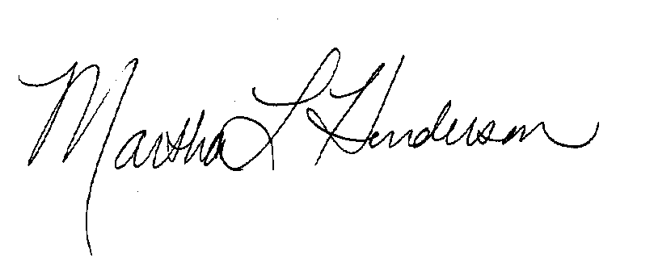  
Martha L Henderson, Ph.D.

Director, Graduate Program on the Environment

(360) 867-6841

mhenders@evergreen.edu