July 30, 2026

FIRST LAST
ADDRESS
CITY STATE ZIP

Dear FIRST, A#: ANUMBER

Thank you for applying for the Graduate Program on the Environment at The Evergreen State College for Fall 2012. Because you did not pay your tuition deposit or confirm you are joining the Master of Environmental Studies Fall 2012 cohort by the deadline outlined in your admission letter, your admission is rescinded and will be given to someone on the waitlist.

If you think this letter is sent in error, please call Gail Wootan at 360-867-6225 or email wootang@evergreen.edu.

Sincerely,

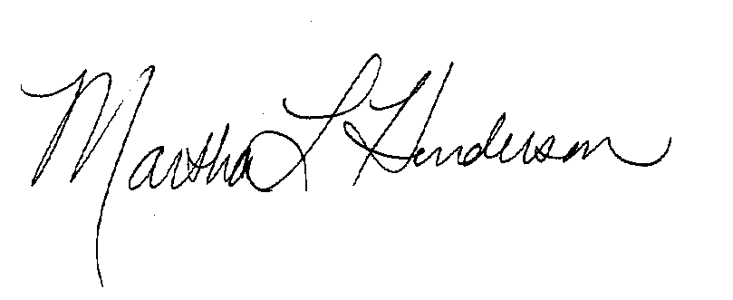

Martha L Henderson, Ph.D.
Director, Graduate Program on the Environment
(360) 867-6841

mhenders@evergreen.edu

