July 30, 2026

FIRST LAST NEW STUDENT ID: ANUMBER
ADDRESS
CITY STATE ZIP

Dear FIRST,

Congratulations! I am pleased to inform you, upon recommendation of the MES Admissions Committee, that you have been accepted into Evergreen’s Fall 2012 Master of Environmental Studies Program.

Your admission to the MES Program is CONDITIONAL based on the following:

- The Graduate Admissions Committee did not see evidence in your application that you have completed, within the last five years, 4 credits of statistics. Completion of this coursework is required before you can begin the core sequence of required MES courses. Please be sure that official transcripts reflecting completion of this work is received by the MES office no later than October 15, 2012. For a list of ways to meet this requirement, go to http://www.evergreen.edu/mes/docs/prereqlist.pdf.

- The Graduate Admissions Committee did not see evidence in your application that you have completed, within the last five years, 4 credits of biological or earth science. Completion of this coursework is required before you can begin the core sequence of required MES courses. Please be sure that official transcripts reflecting completion of this work is received by the MES office no later than October 15, 2012. For a list of ways to meet this requirement, go to http://www.evergreen.edu/mes/docs/prereqlist.pdf.

- The Graduate Admissions Committee did not see evidence in your application that you have completed, within the last five years, 4 credits of economic principles. Completion of this coursework is required before you can begin the core sequence of required MES courses. Please be sure that official transcripts reflecting completion of this work is received by the MES office no later than October 15, 2012. For a list of ways to meet this requirement, go to http://www.evergreen.edu/mes/docs/prereqlist.pdf.

I hope you will be able to join us. As a new MES student, you are required to enroll in the first MES core class: graduate Conceptualizing our Regional Environment, or gCORE. All core courses are on Tuesdays and Thursdays, 6pm-10pm. If you intend to finish in two years, you should also take an elective course along with gCORE. To see more information on our courses, including faculty contact information, please review the MES online catalog at http://www.evergreen.edu/catalog/2011-12/mes. At this time, not all electives are listed – they will be posted as they are confirmed, so check back regularly. Fall registration instructions will come by email from the MES office sometime in June.

This year, classes start September 24, 2012. A one-day orientation to MES will be on September 15, 2012; all new students are required to participate. In mid-August, we will send more specific information to your Evergreen email about orientation if you have accepted this offer of admission. Important notifications from the college and the MES program will be sent to your Evergreen email address periodically, so be sure to set it up immediately (directions enclosed) and check it regularly. Please inform the Admissions Office of any mailing address changes: admissions@evergreen.edu or calling 360-867-6170.

Evergreen also offers a variety of financial aid options. Please go to http://www.evergreen.edu/mes/financial for the types of aid available, such as loans, grants and scholarships. Be sure to apply for the MES-specific awards by April 11. Award descriptions and an online application are at http://www.evergreen.edu/mes/awards.


If you wish to accept this offer of admission, please promptly inform Gail Wootan, the MES Assistant Director, in writing by emailing wootang@evergreen.edu or mailing a letter addressed to MES. Enclosed is a billing form for your tuition deposit. This non-refundable $100.00 deposit reserves your space in the program. In order to hold your space at the institution the college must receive payment by May 31, 2012. If you cannot accept this offer of admission, please notify us in writing immediately so that we can inform students on our waiting list.

We’re looking forward to having you join us. It is with considerable care that we select this class of about forty-five students. We hope this opportunity to participate in our program will be meaningful to you. You will be part of a diverse, capable, and dedicated group of people. I will be pleased to discuss any aspect of the MES Program with you should you have further questions. The MES Program faculty and staff look forward to having you join us in September.

Sincerely,

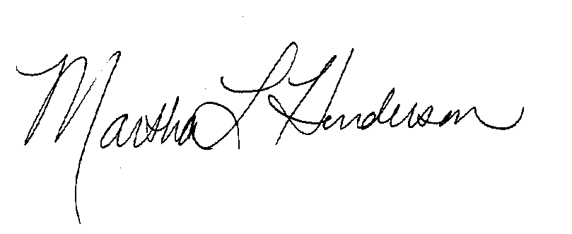
Martha L Henderson, Ph.D.
Director, Graduate Program on the Environment
(360) 867-6841
mhenders@evergreen.edu

