July 29, 2026

Leslie McGhee
PO Box 782
Hoodsport, WA 98548

Dear Leslie, A#: A00068250

Thank you for applying for the Master of Environmental Studies Program at The Evergreen State College for Fall 2011. Because you did not pay your tuition deposit or confirm you are joining MES by the deadline outlined in your admission letter, your admission is rescinded and will be given to someone on the waitlist.

If you think this letter is sent in error, please call Gail Wootan at 360-867-6225 or email wootang@evergreen.edu.

Sincerely,

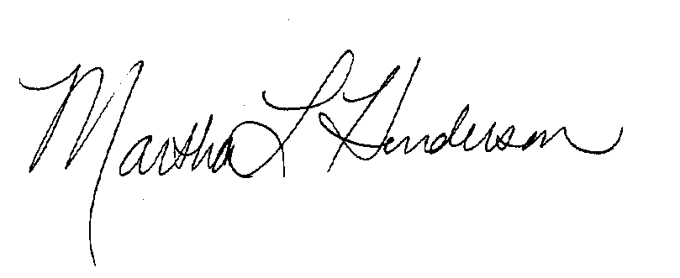

Martha L Henderson, Ph.D.
Director, Graduate Program of Environmental Studies
(360) 867-6841
mhenders@evergreen.edu

July 29, 2026

Jaclyn Marie Schlindwein
1218 20th Ave SE
Olympia, WA 98501

Dear Jaclyn Marie, A#: A00056009

Thank you for applying for the Master of Environmental Studies Program at The Evergreen State College for Fall 2011. Because you did not pay your tuition deposit or confirm you are joining MES by the deadline outlined in your admission letter, your admission is rescinded and will be given to someone on the waitlist.

If you think this letter is sent in error, please call Gail Wootan at 360-867-6225 or email wootang@evergreen.edu.

Sincerely,

Martha L Henderson, Ph.D.
Director, Graduate Program of Environmental Studies
(360) 867-6841
mhenders@evergreen.edu
July 29, 2026

Elizabeth Fairbank
203 Crimmons Cir
Cary, NC 27511

Dear Elizabeth, A#: A00268157

Thank you for applying for the Master of Environmental Studies Program at The Evergreen State College for Fall 2011. Because you did not pay your tuition deposit or confirm you are joining MES by the deadline outlined in your admission letter, your admission is rescinded and will be given to someone on the waitlist.

If you think this letter is sent in error, please call Gail Wootan at 360-867-6225 or email wootang@evergreen.edu.

Sincerely,

Martha L Henderson, Ph.D.
Director, Graduate Program of Environmental Studies
(360) 867-6841
mhenders@evergreen.edu
July 29, 2026

Tiffanie Ramos
12082 Jacalene Ln
Garden Grove, CA 92840

Dear Tiffanie, A#: A00268355

Thank you for applying for the Master of Environmental Studies Program at The Evergreen State College for Fall 2011. Because you did not pay your tuition deposit or confirm you are joining MES by the deadline outlined in your admission letter, your admission is rescinded and will be given to someone on the waitlist.

If you think this letter is sent in error, please call Gail Wootan at 360-867-6225 or email wootang@evergreen.edu.

Sincerely,

Martha L Henderson, Ph.D.
Director, Graduate Program of Environmental Studies
(360) 867-6841
mhenders@evergreen.edu
July 29, 2026

Nicholas Rivas
2511 SE Pine St
Portland, OR 97214

Dear Nicholas, A#: A00268768

Thank you for applying for the Master of Environmental Studies Program at The Evergreen State College for Fall 2011. Because you did not pay your tuition deposit or confirm you are joining MES by the deadline outlined in your admission letter, your admission is rescinded and will be given to someone on the waitlist.

If you think this letter is sent in error, please call Gail Wootan at 360-867-6225 or email wootang@evergreen.edu.

Sincerely,

Martha L Henderson, Ph.D.
Director, Graduate Program of Environmental Studies
(360) 867-6841
mhenders@evergreen.edu
July 29, 2026

Rebecca Rosa
125 N Orange Ave
Lodi, CA 95240

Dear Rebecca, A#: A00270345

Thank you for applying for the Master of Environmental Studies Program at The Evergreen State College for Fall 2011. Because you did not pay your tuition deposit or confirm you are joining MES by the deadline outlined in your admission letter, your admission is rescinded and will be given to someone on the waitlist.

If you think this letter is sent in error, please call Gail Wootan at 360-867-6225 or email wootang@evergreen.edu.

Sincerely,

Martha L Henderson, Ph.D.
Director, Graduate Program of Environmental Studies
(360) 867-6841
mhenders@evergreen.edu
July 29, 2026

Jacob Stone
1379 Chatley Way
Woodstock, GA 30188

Dear Jacob, A#: A00270518

Thank you for applying for the Master of Environmental Studies Program at The Evergreen State College for Fall 2011. Because you did not pay your tuition deposit or confirm you are joining MES by the deadline outlined in your admission letter, your admission is rescinded and will be given to someone on the waitlist.

If you think this letter is sent in error, please call Gail Wootan at 360-867-6225 or email wootang@evergreen.edu.

Sincerely,

Martha L Henderson, Ph.D.
Director, Graduate Program of Environmental Studies
(360) 867-6841
mhenders@evergreen.edu
July 29, 2026

Shivon Van Allen
9706 NE 21st Pl
Vancouver, WA 98665

Dear Shivon, A#: A00114077

Thank you for applying for the Master of Environmental Studies Program at The Evergreen State College for Fall 2011. Because you did not pay your tuition deposit or confirm you are joining MES by the deadline outlined in your admission letter, your admission is rescinded and will be given to someone on the waitlist.

If you think this letter is sent in error, please call Gail Wootan at 360-867-6225 or email wootang@evergreen.edu.

Sincerely,

Martha L Henderson, Ph.D.
Director, Graduate Program of Environmental Studies
(360) 867-6841
mhenders@evergreen.edu
July 29, 2026

Jacqueline Weidman
160 Bayberry Lane
Watchung, NJ 07069

Dear Jacqueline, A#: A00269788

Thank you for applying for the Master of Environmental Studies Program at The Evergreen State College for Fall 2011. Because you did not pay your tuition deposit or confirm you are joining MES by the deadline outlined in your admission letter, your admission is rescinded and will be given to someone on the waitlist.

If you think this letter is sent in error, please call Gail Wootan at 360-867-6225 or email wootang@evergreen.edu.

Sincerely,

Martha L Henderson, Ph.D.
Director, Graduate Program of Environmental Studies
(360) 867-6841
mhenders@evergreen.edu

