July 30, 2026

FIRST LAST NEW STUDENT ID: ANUMBER
ADDRESS
CITY STATE ZIP

Dear FIRST,

Congratulations! I am pleased to inform you, upon recommendation of the MES Admissions Committee, that you have been accepted into Evergreen’s Fall 2012 Master of Environmental Studies Program.


I hope you will be able to join us. If you wish to accept this offer of admission, please promptly inform Gail Wootan, the MES Assistant Director, in writing by emailing wootang@evergreen.edu or mailing a letter addressed to MES. Enclosed is a billing form for your tuition deposit. This non-refundable $100.00 deposit reserves your space in the program. In order to hold your space at the institution the college must receive payment by May 31, 2012. If you cannot accept this offer of admission, please notify us in writing immediately so that we can inform students on our waiting list.

This year, classes start September 24, 2012. A one-day orientation to the Master of Environmental Studies Program will be held September 15, 2012, and all new students are required to participate. In mid-August, we will send more specific information to your evergreen.edu email about this orientation meeting if you have confirmed your enrollment by sending your deposit. Important notifications from the college and the MES program will be sent to your Evergreen email address periodically, so be sure to set it up immediately (directions enclosed) and check it regularly. Please inform the Admissions Office of any changes in your mailing address by emailing admissions@evergreen.edu or calling 360-867-6170.

I encourage you to review the MES course selections carefully; you may review our catalog online at www.evergreen.edu/catalog (make sure to choose “Environmental Studies” on the left). Evergreen also offers a variety of financial aid options. Please go to http://www.evergreen.edu/mes/financial for a description of available aid—some awards may have already been awarded or have quickly approaching deadlines.

We’re looking forward to having you join us. It is with considerable care that we select this class of approximately forty students. We hope this opportunity to participate in our program will be meaningful to you. You will be part of a diverse, capable, and dedicated group of people. I will be pleased to discuss any aspect of the MES Program with you should you have further questions. The MES Program faculty and staff look forward to having you join us in September.

Sincerely,

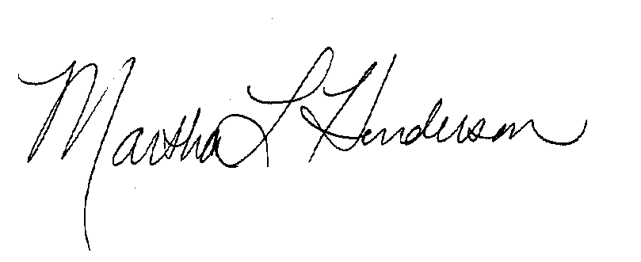
Martha L Henderson, Ph.D.
Director, Graduate Program on the Environment
(360) 867-6841
mhenders@evergreen.edu

