July 29, 2026

Brooke L Clement NEW STUDENT ID: A08005238
2012 148th St SE
Mill Creek, WA 98012

Dear Brooke,

Congratulations! I am pleased to inform you, upon recommendation of the Graduate Admissions Committee, that you have been accepted into Evergreen’s Fall 2010 Master of Environmental Studies Program.

Your admission to the MES Program is PROVISIONAL based on the fact that your file does not contain an official transcript indicating you have been awarded a baccalaureate (bachelor’s) degree. In order for you to enroll for the Fall Quarter, the Admissions Office must receive written confirmation by September 15, 2010 from an official of the awarding institution indicating you have completed the requirements for your bachelor’s degree. In addition, by October 31, 2010, the Admissions Office must receive an official transcript reflecting the awarding of the bachelor’s degree in order for you to continue in the MES Program beyond the Fall Quarter. If you are awarded financial aid, please note that your final transcript reflecting award of the Bachelor’s degree must be received by September 15, 2010 in order for any financial aid funds to be released for Fall Quarter.

I hope you will be able to join us. If you wish to accept this offer of admission, please promptly inform the Admissions Office in writing. Enclosed is a billing form for your tuition deposit. This non-refundable $100.00 deposit reserves your space in the program. In order to hold your space at the institution the college must receive payment within 30 days from the date of this letter. If you cannot accept this offer of admission, please notify us in writing immediately so that we can inform students on our waiting list.

This year, classes start on Monday, September 27, 2010. An orientation to the Graduate Program in Environmental Studies will be held in September and all new students are expected to participate. In mid August, we will send more specific information about this orientation meeting to all students who have confirmed their enrollment by sending their deposit (see below). Please inform the Admissions Office of any changes in your mailing address, so we can get this information to you on time.

We’re looking forward to having you join us. You are welcome to begin your graduate studies at Evergreen by taking elective courses this summer. I encourage you to review the MES Graduate Studies Catalog carefully. If you do not have a copy, please request one from the Admissions Office (360) 867-6170 or review our updated catalog online at www.evergreen.edu/mes for more information about our elective courses.

Sincerely,
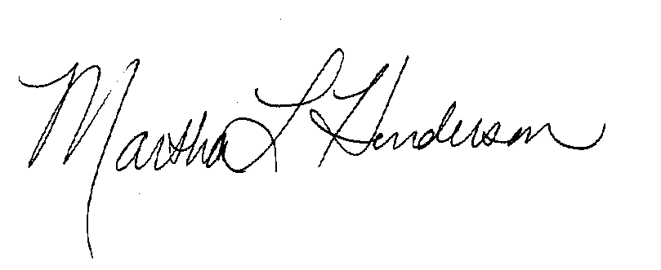
Martha L Henderson, Ph.D.
Director, Graduate Program of Environmental Studies
(360) 867-6841
mhenders@evergreen.edu

