July 30, 2026

Jody Christine Burnett NEW STUDENT ID: A00240765
PO Box 549
Janesville, MN 56048

Dear Jody,

Congratulations! I am pleased to inform you, upon recommendation of the Graduate Admissions Committee, that you have been accepted into Evergreen’s Fall 2010 Masters of Environmental Studies Program.

Your admission to the MES Program is PROVISIONAL based on the fact that your file does not contain an official transcript indicating you have been awarded a baccalaureate (bachelor’s) degree. In order for you to enroll for the Fall Quarter, the Admissions Office must receive written confirmation by September 15, 2010 from an official of the awarding institution indicating you have completed the requirements for your bachelor’s degree. In addition, by September 11, 2010, the Admissions Office must receive an official transcript reflecting the awarding of the bachelor’s degree in order for you to continue in the MES Program beyond the Fall Quarter. If you are awarded financial aid, please note that your final transcript reflecting award of the Bachelor’s degree must be received by September 11, 2010 in order for any financial aid funds to be released for Fall Quarter.

Your admission to the MES Program is also CONDITIONAL based on the following:

- The Graduate Admissions Committee did not see evidence in your application that you have completed, within the last five years, 4 credits of introductory statistics. Completion of this coursework is required before you can begin the core sequence of required MES courses. Please see that official transcripts reflecting completion of this work is received by the Evergreen Admissions Office no later than October 16, 2010.

I hope you will be able to join us. If you wish to accept this offer of admission, please promptly inform the Admissions Office in writing. Enclosed is a billing form for your tuition deposit. This non-refundable $100.00 deposit reserves your space in the program. In order to hold your space at the institution the college must receive payment within 30 days from the date of this letter. If you cannot accept this offer of admission, please notify us in writing immediately so that we can inform students on our waiting list.

This year, classes start on Monday, September 27, 2010. An orientation to the MES Program will be held in September and all new students are expected to participate. In mid August, we will send more specific information about this orientation meeting to all students who have confirmed their enrollment by sending their deposit (see below). Please inform the Admissions Office of any changes in your mailing address, so we can get this information to you on time.

We’re looking forward to having you join us. It is with considerable care that we select this class of approximately forty students. We hope this opportunity to participate in our program will be meaningful to you. You will be part of a diverse, capable, and dedicated group of people. I will be pleased to discuss any aspect of the MES Program with you should you have further questions. The MES Program faculty and staff look forward to having you join us in September.

Sincerely,
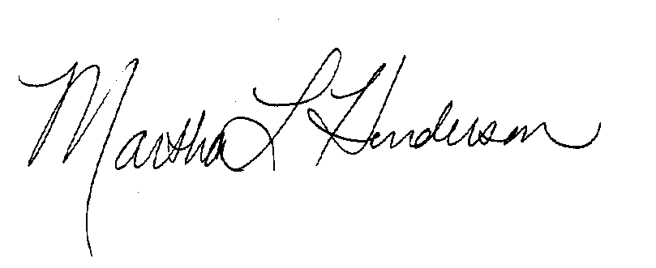
Martha L Henderson, Ph.D.
Director, Graduate Program of Environmental Studies
(360) 867-6841
mhenders@evergreen.edu

