July 30, 2026

STUDENT NAME NEW STUDENT ID:
STUDENT ADDRESS

Dear STUDENT,

Congratulations! We are pleased to inform you, upon recommendation of the Graduate Admissions Committee, that you have been accepted into Evergreen’s Fall 2010 Master of Environmental Studies Program as a joint Master of Environmental Studies/Master of Public Administration student.

I hope you will be able to join us. If you wish to accept this offer of admission, please promptly inform the Admissions Office in writing. Enclosed is a billing form for your tuition deposit. This non-refundable $100.00 deposit reserves your space in the program. In order to hold your space at the institution the college must receive payment within 30 days from the date of this letter. If you cannot accept this offer of admission, please notify us in writing immediately so that we can inform students on our waiting list.

As a joint MES/MPA student, you will join the 2010-2011 MES cohort in your first year, join the 2011-2012 MPA cohort your second year, and in your third year, you will join a different MES cohort so that you can finish up MES core classes and work on your thesis. Please see WEBSITE for a more detailed explanation of the MES/MPA degree path.

An orientation to the Master of Environmental Studies Program will be held in September, and all new MES and MES/MPA students are expected to participate. In mid August, we will send more specific information about this orientation meeting to all students who have confirmed their enrollment by sending their deposit (see below). Please inform the Admissions Office of any changes in your mailing address, so we can get this information to you on time. In your second year, you will be asked to join the MPA orientation in September 2011.

You are welcome to begin your graduate studies at Evergreen by taking elective courses this summer. I encourage you to review the MES Graduate Studies Catalog carefully, you may review our updated catalog online at www.evergreen.edu/mes for more information about our elective courses.

We’re looking forward to having you join us. It is with considerable care that we select this MES class of approximately forty students. We hope this opportunity to participate in our program will be meaningful to you. You will be part of a diverse, capable, and dedicated group of people. We will be pleased to discuss any aspect of either program with you should you have further questions. The MES Program faculty and staff look forward to having you join us in September.

Sincerely,
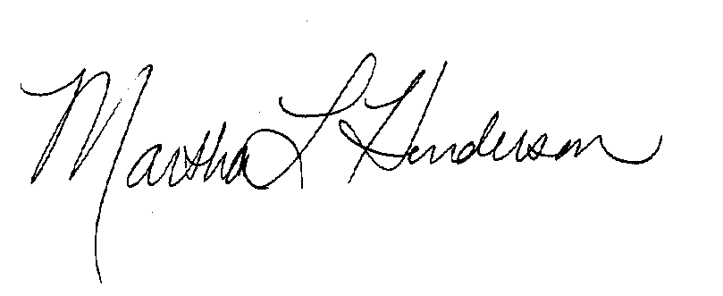
Martha L Henderson, Ph.D.
Director, Graduate Program of Environmental Studies
(360) 867-6841
mhenders@evergreen.edu

Cheryl’s signature

Cheryl Simrell King, Ph. D.
Director, Master of Public Administration
(360) 867-5541
kingcs@evergreen.edu

