March 10, 2014

FIRST LAST

ADDRESS

CITY STATE ZIP

Dear FIRST,

I regret to inform you that the Graduate Program on the Environment Admissions Committee is unable to offer you admission to the Fall 2014 cohort of the Master of Environmental Studies degree. Should you be interested in applying again next year, you do not have to resubmit transcripts or GRE scores (unless they expire). Letters of recommendation also do not have to be resubmitted, but it is recommended that you consider sending in new letters to reflect your growth over the last year.

We appreciate your interest in the program and wish you the best of luck in your future ventures.

Sincerely,

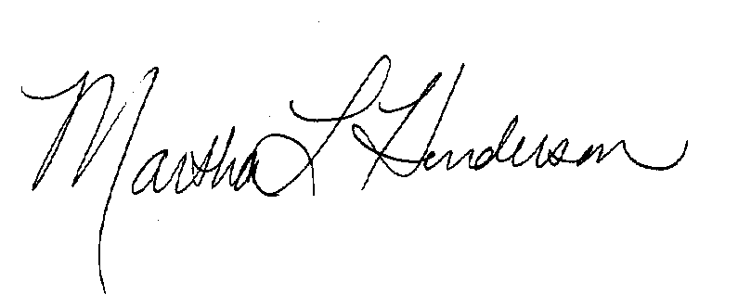

Martha L Henderson, Ph.D.

Director, Graduate Program on the Environment

(360) 867-6841

mhenders@evergreen.edu